The Big Earth Data Project

Lesson 3: Identifying regions in scatter diagrams

Interpreting scatter diagrams and correlation coefficients
- What type of correlation is shown in each diagram (positive/negative)?
- Which show that strongest correlation?
- Ozone starts to break down when the temperature is below -78°C and there is sufficient sunlight. Are the scatter diagrams consistent with this?
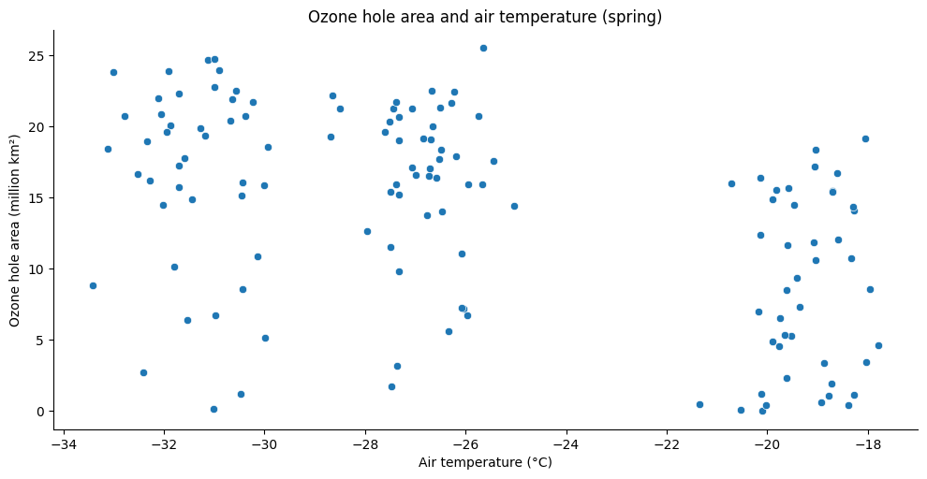Correlation coefficient: $r=-0.477$
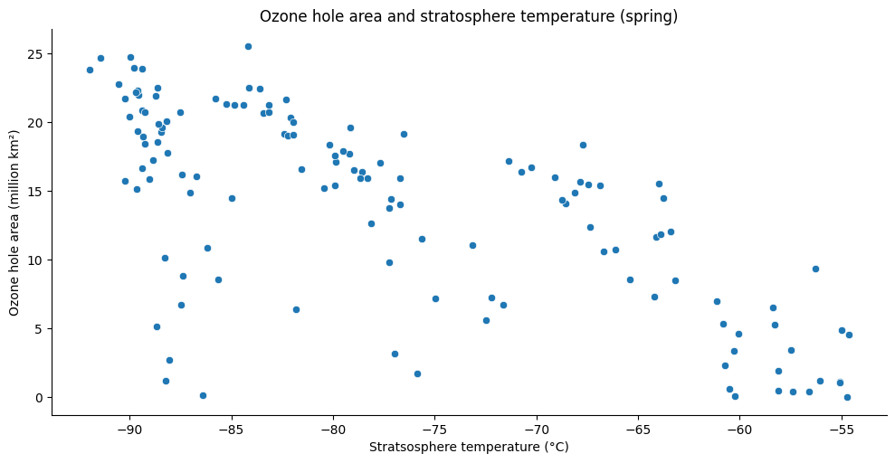
Correlation coefficient: $r=-0.686$

Finding regions is scatter plots
- What patterns are there in the diagrams?
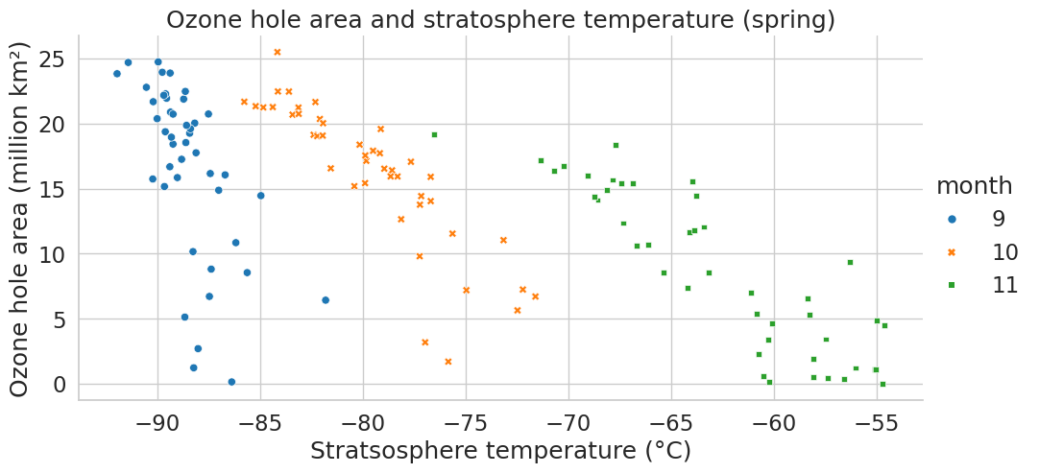
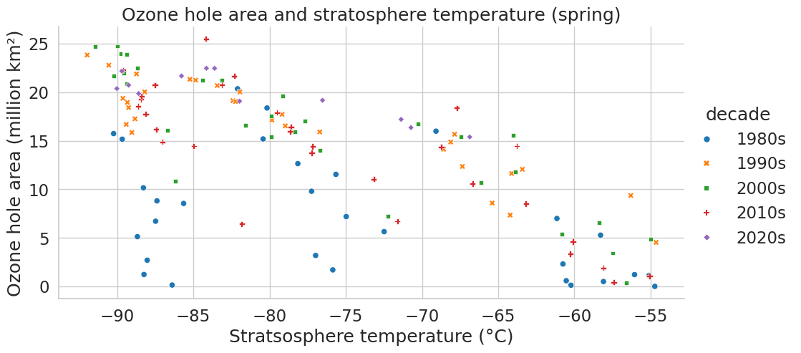

Exploring the correlation in a region of a scatter plot
- Which shows the strongest and which show the weakest correlation?
- How does this compare to the correlation for the data for the whole of spring?
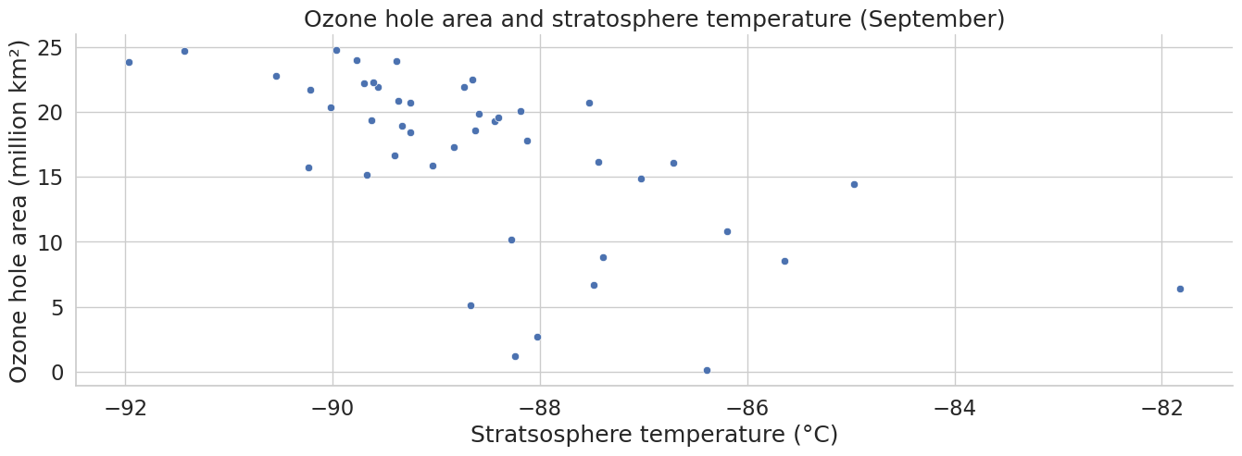Correlation coefficient: $r=-0.615$
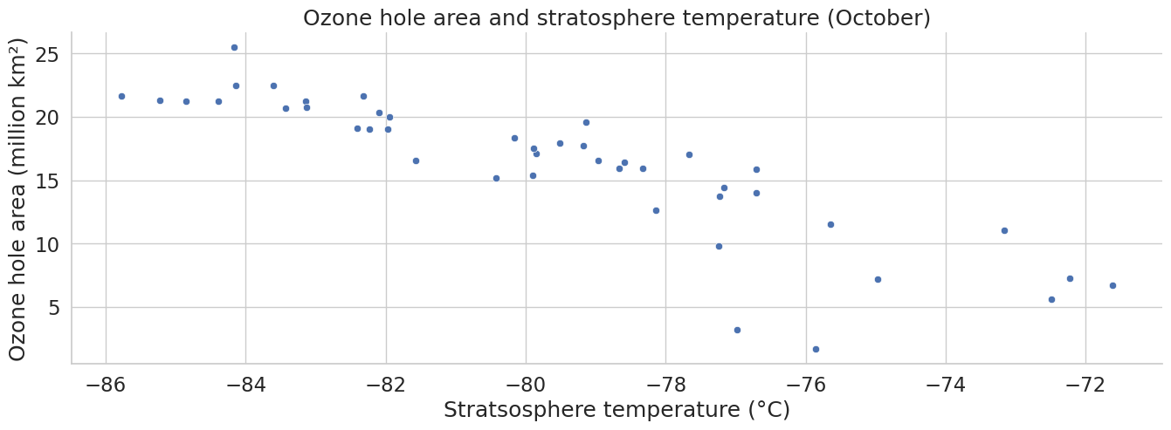
Correlation coefficient: $r=-0.886$
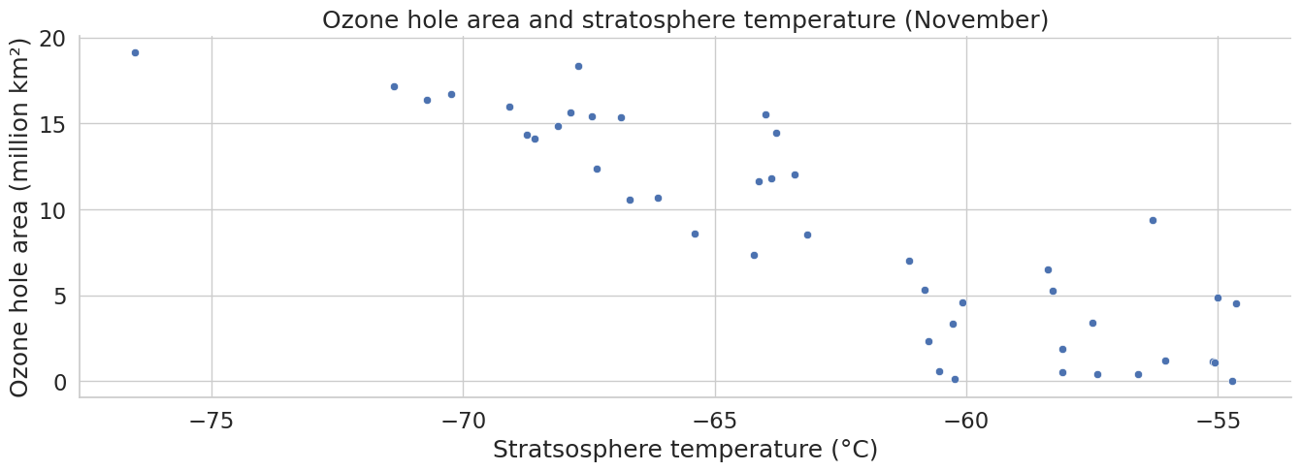
Correlation coefficient: $r=-0.883$

