The Big Earth Data Project

Lesson 1: Diagrams for single variable data
Exploring the area of the hole in the ozone layer for different seasons
- What feature of the diagram shows that the hole in the ozone layer mostly occurs in the southern hemisphere spring?
- Which are the strengths and weaknesses of each diagram?
Box plots
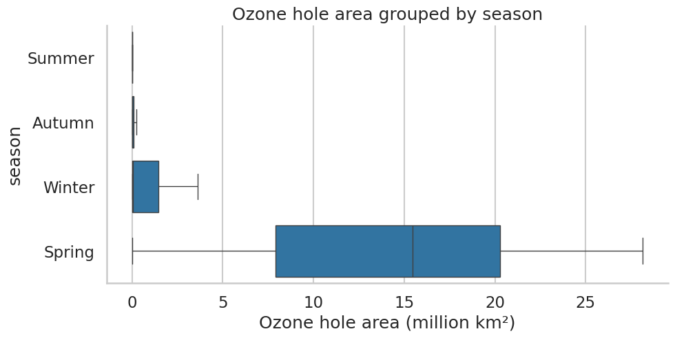
Strip plot
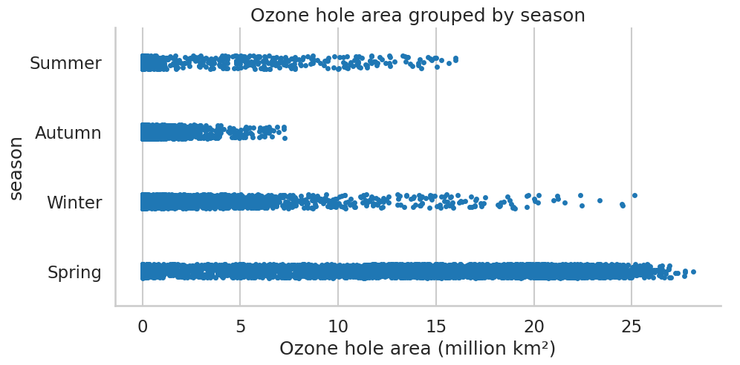
Separate histograms
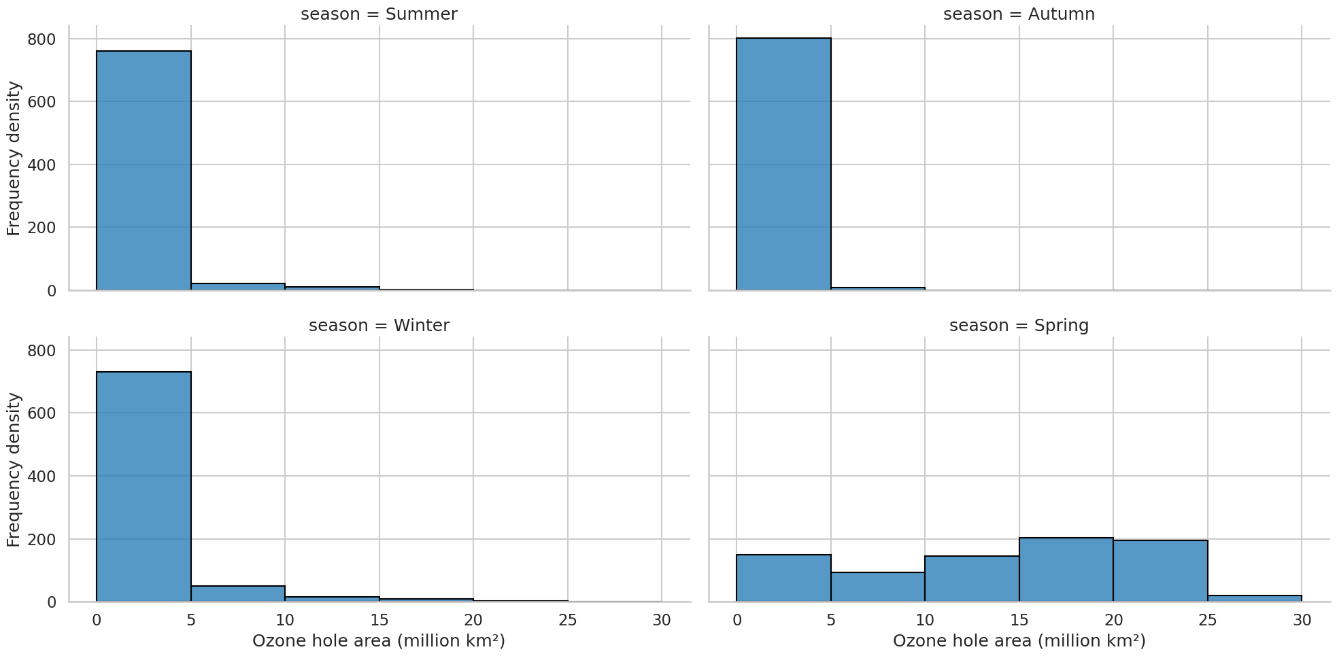
Frequency polygons
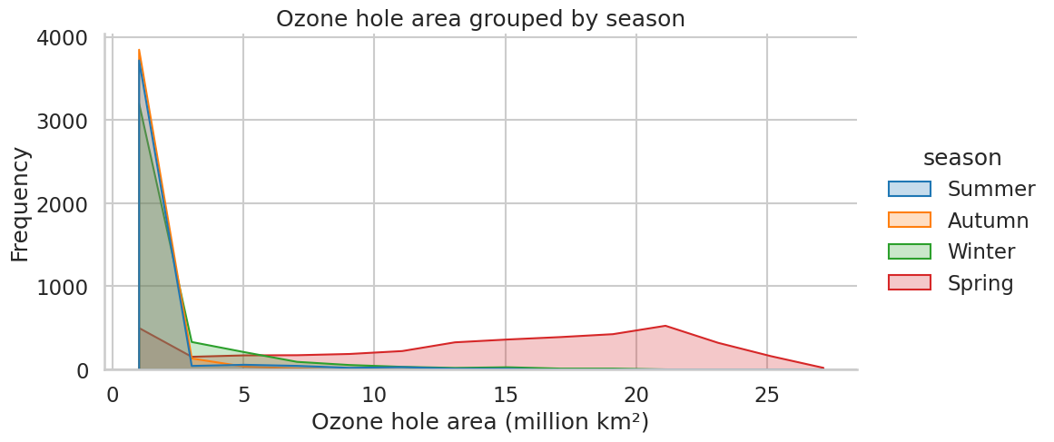

Exploring the hole in the ozone layer for different decades (spring data)
- What features of the diagrams show a reduction in the size of the hole from 1990 through to 2019?
- Scientists believe that the hole is still reducing but that there is not enough data yet from 2020s to confirm this. What features of the diagrams show that there is less data from the 2020s?
- Which diagrams do you find the most useful and which diagrams do you find the least useful?
Box plots
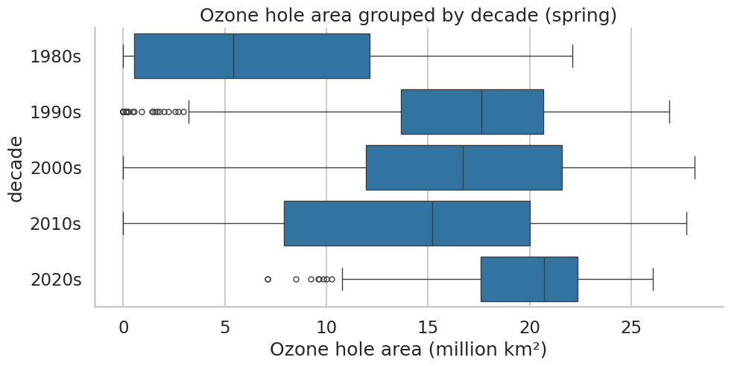
Strip plots
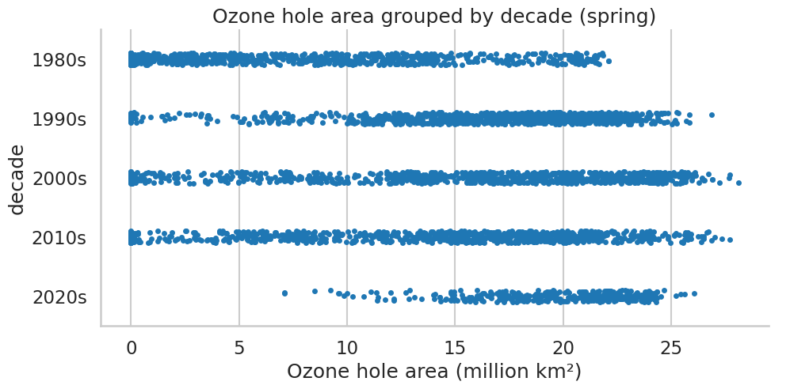

Separate histograms
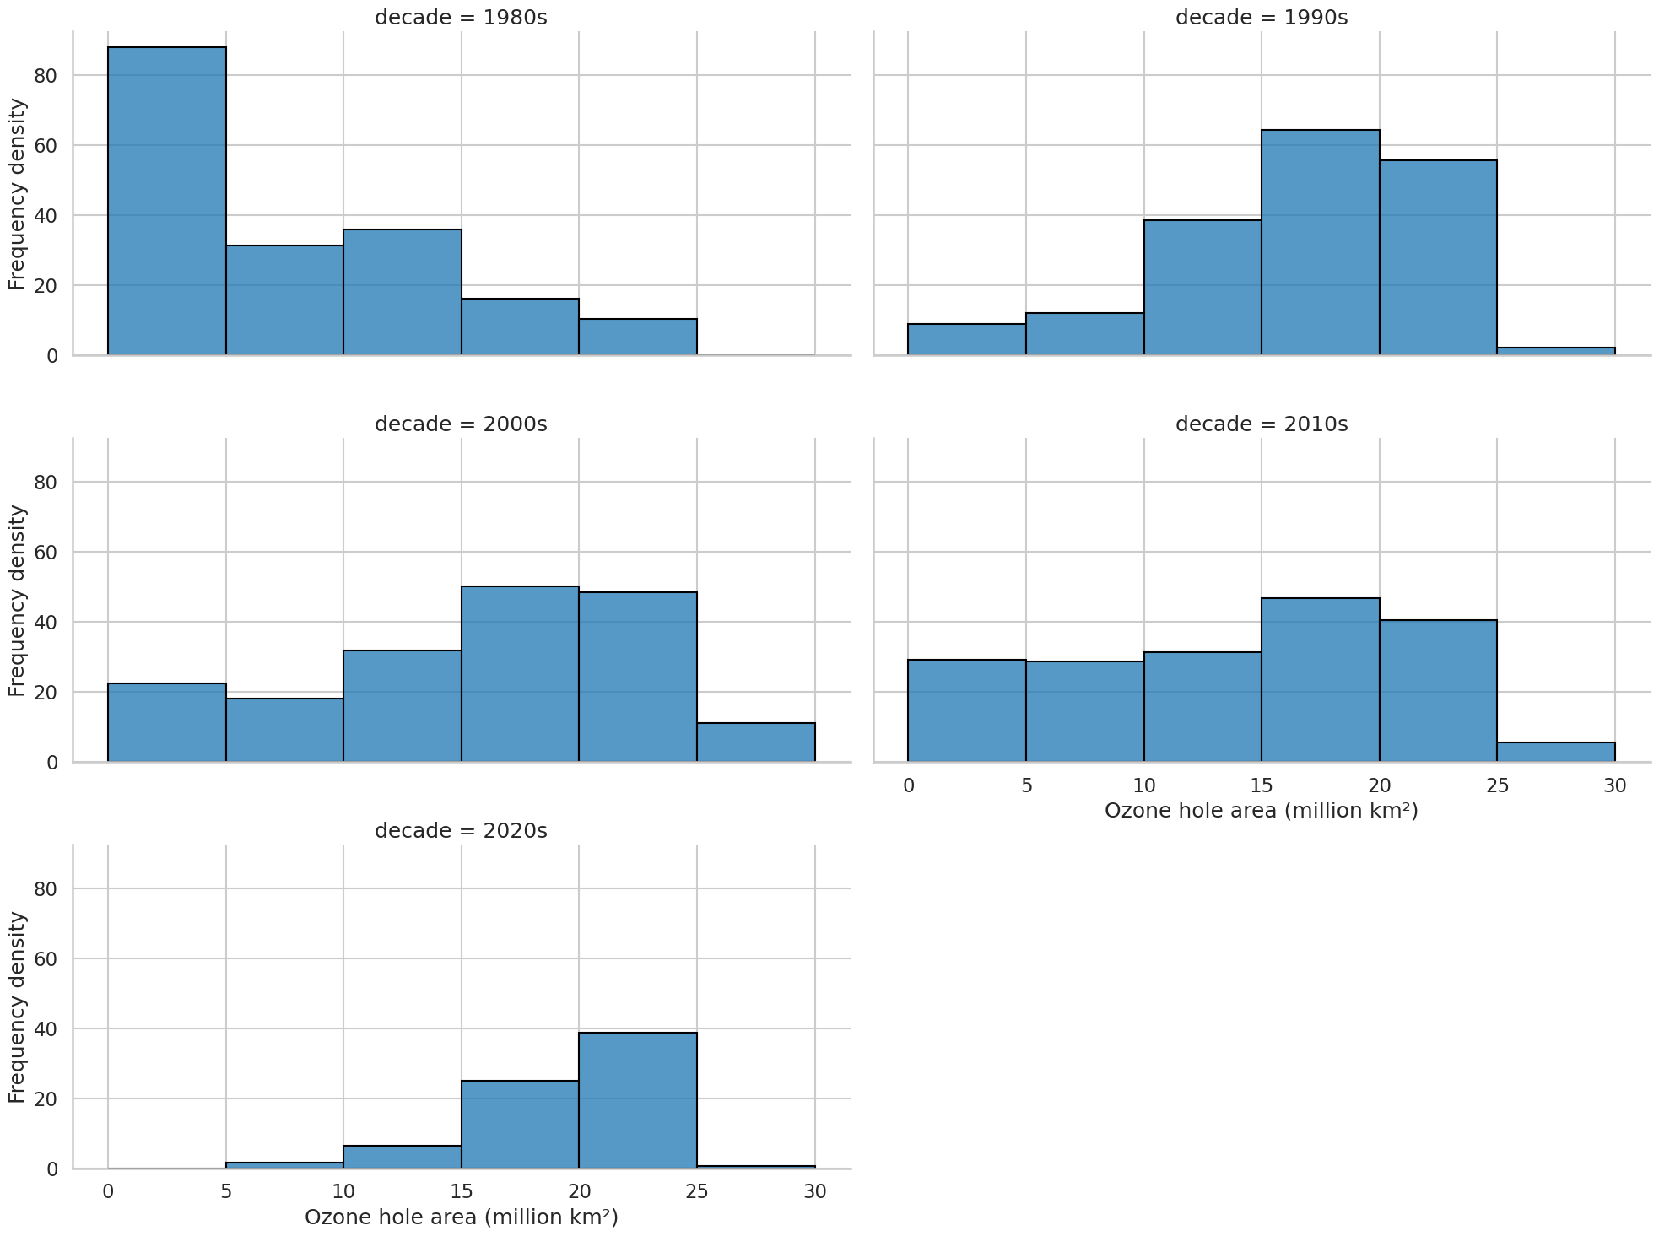
Frequency polygons
