Lesson 1: Atmosphere activities – handout
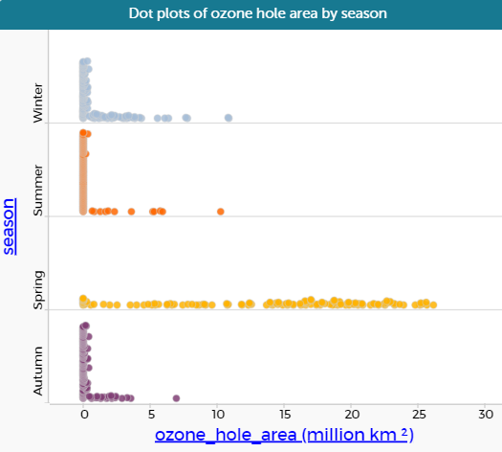
Each of the dots on the graph represents the size of the ozone hole in a particular month.
- In which season are the largest areas?
- How easy is it to tell the differences between the seasons?
- What other graphs and calculations would give us some more information?

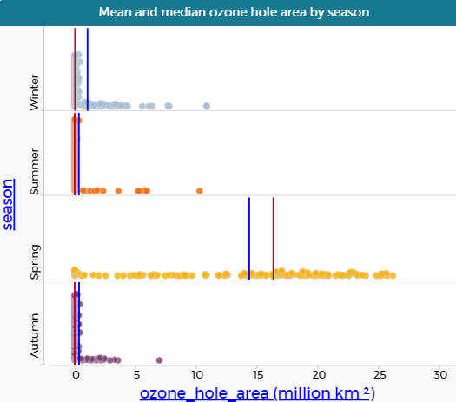
In each of the diagrams, the red line represents the median value and the blue line is the mean.
- Why is the median lower than the mean for 3 of the seasons?
- Which average is better to use?
- Would the mode be useful in this situation? Why/Why not?

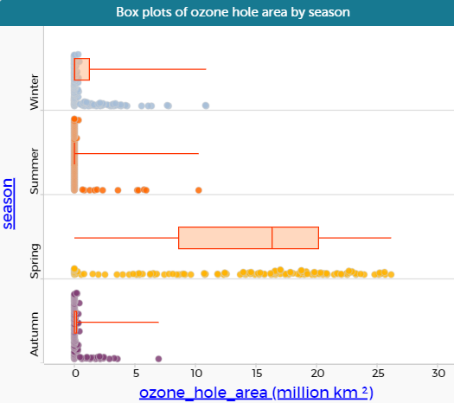
The graph now shows box plots for each of the seasons
- What are the 5 pieces of information that a box plot shows?
- Which of the seasons has the most variation in ozone hole area?
- Which has the least?
- Why does Summer appear to have no box?
- Which measure of spread do you think would be most useful to use to compare the seasons?
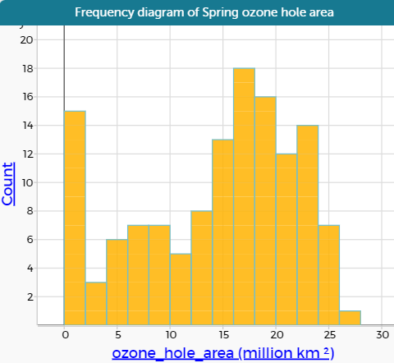

The diagram shows how many months there were with ozone holes of different sizes
- Is it clearer than the box plot?
- Which is the most common ozone hole area in Spring?
- Is the number of months with 0 to 2 million square kilometres ozone hole area larger than you thought from the box plot?

