Lesson 2: Atmosphere activities – Time Series handout

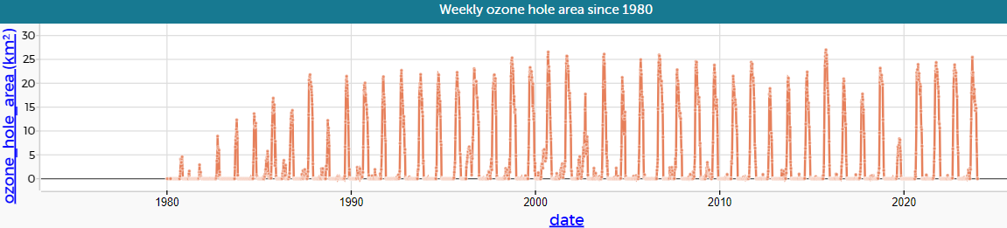
- What can we tell about how the ozone hole has changed over time?
- Which year has the maximum value?
- What could we do to make this graph better?

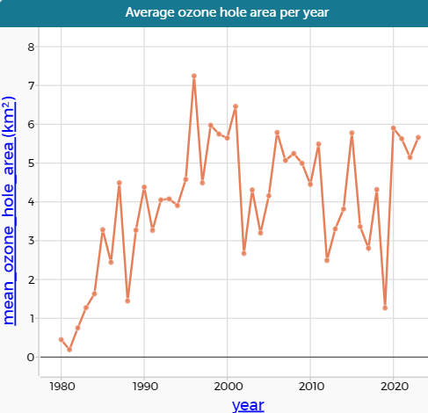
a) Is this a more useful graph than the time series for individual days? Are the trends more obvious?

b) What are the similarities in the trend of the two graphs?

c) What are the differences?

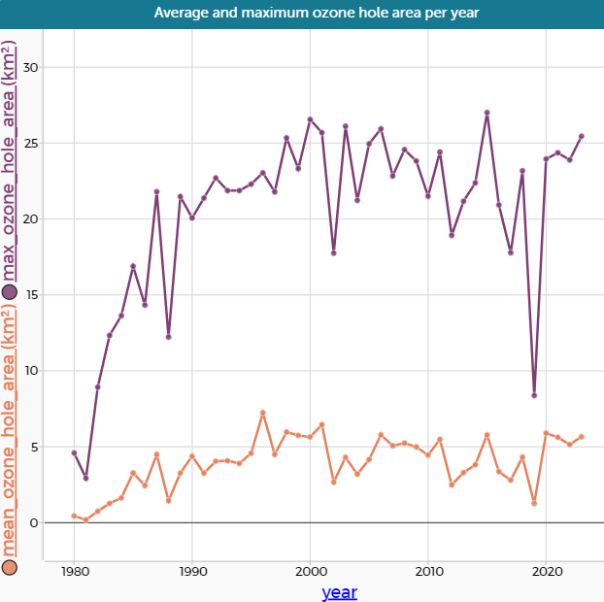
The graph shows both the maximum and the mean ozone hole area for each month
- Can you describe the differences or similarities in shape?
- Why might the maximum ozone hole area be more useful than the mean?

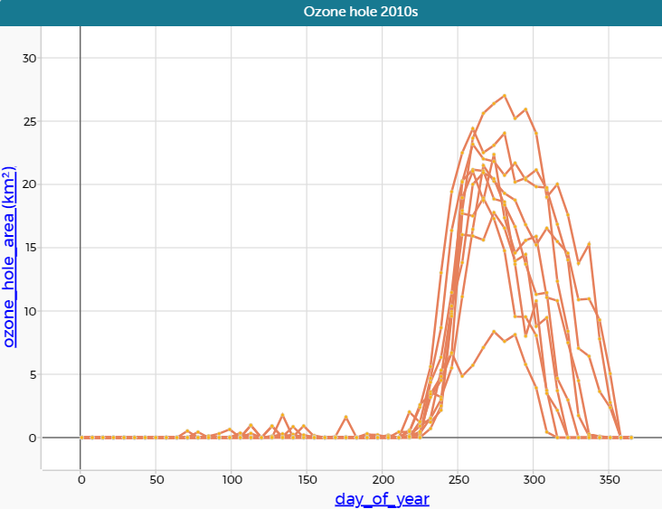
The diagram shows how many months there were with ozone holes of different sizes
a) Is it clearer than the box plot?
b) Which is the most common ozone hole area in Spring?
c) Is the number of months with 0 to 2 million square kilometres ozone hole area larger than you thought from the box plot?

