Problem solving (AS)

A1 | [Understand and use the structure of mathematical proof, proceeding from given assumptions through a series of logical steps to a conclusion; use methods of proof, including proof by deduction, proof by exhaustion]  [Disproof by counter example]

Commentary

There are three Overarching Themes which should pervade the teaching and learning of A level Mathematics: mathematical argument, language and proof; mathematical problem-solving; and mathematical modelling. This unit serves as an introduction to each of them, without introducing any new mathematical content.

Mathematical argument, language and proof. Students meet proof by direct argument and by exhaustion, as well as disproof by counterexample. A proof verifies that a statement is true; a good proof explains why it is true, giving deeper insights into the underlying mathematics. For example, think how adding the radius OB to a circle centre O, diameter AC, helps to explain why the angle ABC must be a right angle. Aim to show students that proofs are not series of steps to be remembered but are ways of thinking mathematically.

Mathematical problem-solving. The DfE guidelines say that the new A level ‘must encourage students to use their mathematical skills and techniques to solve challenging problems which require them to decide on the solution strategy, and to use their mathematical knowledge to make logical and reasoned decisions in solving problems both within pure mathematics and in a variety of contexts, and communicate the mathematical rationale for these decisions clearly.’ This unit aims to tackle problems that are presented in an unstructured form, which have little or no scaffolding, and which ideally invite a variety of techniques.

Mathematical modelling.
The modelling cycle involves
- taking a problem, possibly from the physical world,
- making simplifying assumptions and defining constants and variables to translate it into a mathematical problem,
- solving or analysing this problem using mathematical techniques,
- interpreting the outcome in terms of the real situation,
- carrying out further iterations using different assumptions or a new mathematical model if the output is not in line with the real situation.
Mathematical modelling happens a lot even at GCSE: for example, when finding the area of a circular patio stone, it is modelled as a perfect circle even though in reality this will not be the case. In the bouncing ball problem in the sample resource below, how has the situation been modelled? Would a student observing such a ball model it in this way? How realistic is the model? Students should be aware of how they regularly use mathematical models to analyse real situations.

Sample MEI resource

‘Problem solving posters’ (which can be found at https://my.integralmaths.org/integral/sow-resources.php) are produced by MEI’s Further Maths Support Programme. They contain six problems which can be accessed by students starting A level Mathematics and provide an opportunity to focus on the three Overarching Themes.

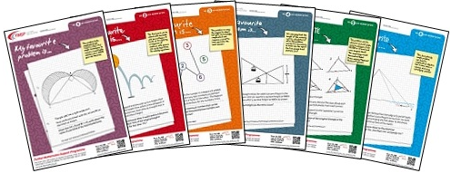

Effective use of technology

‘Points, lines and rectangles’ (which can be found at www.mei.org.uk/integrating-technology) is designed to be used in the first week of an A level course, with the focus on students using GeoGebra in a problem solving context.

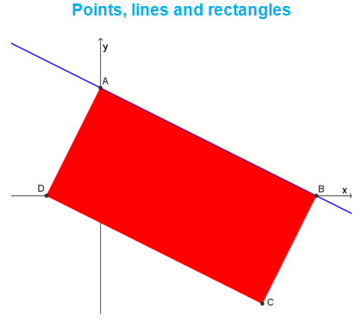

- As a teacher looking at this diagram, what questions spring to mind?
- Which problems is it reasonable for new A level students to be able to tackle?
- How might access to GeoGebra extend this range of problems?

Problem solving (AS) | Time allocation:
Pre-requisites
- This first unit is designed to look at a range of topics from GCSE with which your students are comfortable, with a focus on problem solving, proof and modelling.

Links with other topics
- Preparation for all A level topics that follow
- Proof: Proof by contradiction is in A level rather than AS
- Modelling: This is particularly useful in the Mechanics and Statistics chapters

Questions and prompts for mathematical thinking
- (Proof) Give me an example of an algebraic/geometric proof you encountered in GCSE Mathematics.
- (Problem solving) At what time between 1.05pm and 1.10pm are the minute and hour hands of a clock exactly on top of each other?
- (Modelling) As many £1 coins as possible are placed flat on a sheet of A4 paper without overlapping the edges of the paper. Estimate the total value of the coins and the percentage of the paper which can be seen through the gaps between the coins. Write down the assumptions you made in arriving at your estimates.

Opportunities for proof
- Review proofs from GCSE: quadratic formula, circle theorems, Pythagoras’ theorem.
- Find a prime number greater than 3 that is one less than a square number. [The factorisation of shows there are no such primes.]

Common errors
- Inaccuracies in algebraic manipulation
- Insufficient clarity in describing the steps in a proof
- Relying too much on a numerical (substitution) approach whereby simple algebraic factorisation would do.

