**Surds and Indices (AS)**

|  |  |
| --- | --- |
| **B1** | [Understand and use the laws of indices for all rational exponents] |
| **B2** | [Use and manipulate surds, including rationalising the denominator] |

**Commentary**

Operations on surds merit some thought. How would you expect your students to explain why  and  but ? And of the equivalent forms  and , why is the latter said to be the simplified version?

The shorthand definition  for , first used by Descartes in 1637, leads into the rules of indices, such as ; these are seen to be true simply by counting terms. The rules can then be used to *define* what is meant by negative and fractional indices, as John Wallis did in 1655. The definition leads to a set of rules that are chosen to extend in a natural way to define new expressions like , which are no longer simply shorthand definitions. In this way  and  are quite different mathematical ideas.

At A level we are concerned only with rational powers. Notice that the rules do not naturally extend to irrational powers; accepting that a number like exists is different from understanding what it means. Whereas  can be thought of as ‘that number which, when raised to the power of 5, equals 49’,  cannot be thought of in such straightforward terms – it requires limiting processes but this is beyond the scope of A level.

**Sample MEI resource**

‘Surds arithmagons’ (which can be found at <https://my.integralmaths.org/integral/sow-resources.php>) is designed to help students appreciate the inverse processes of multiplication and division of surds.

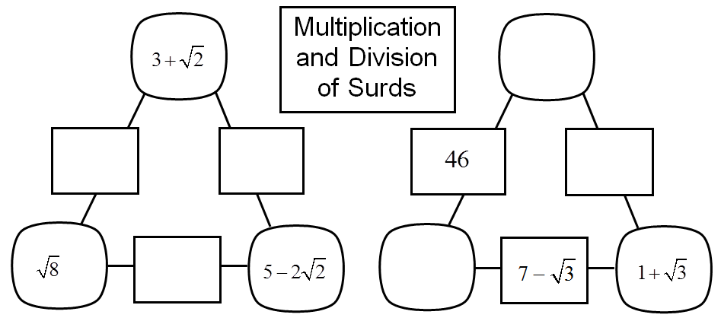

**Effective use of technology**

‘Powers maze’ (which can be found at [www.mei.org.uk/integrating-technology](http://www.mei.org.uk/integrating-technology) ) is designed to encourage students to practise basic manipulations before moving on to more challenging tasks. Here are two screen shots of tasks in which you move the dark blue square through the grid.

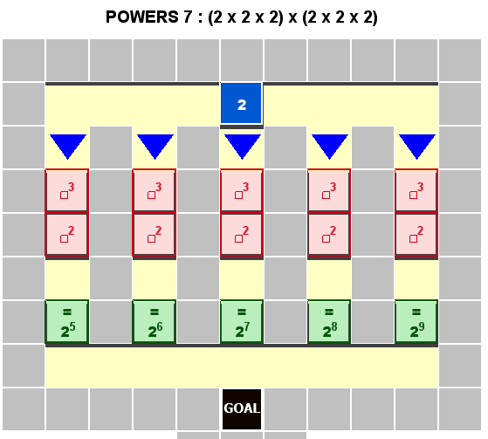 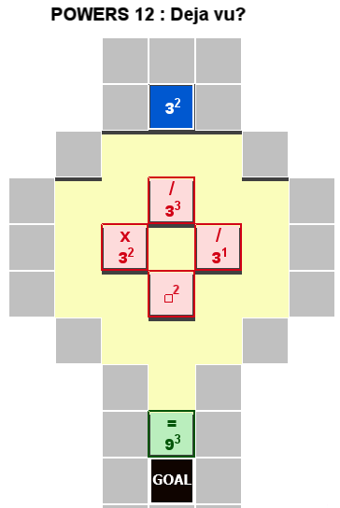

|  |  |
| --- | --- |
| **Surds and Indices (AS)** | **Time allocation:** |
| **Pre-requisites**   * + - * GCSE: Higher Tier students will have met laws of indices and surds | |
| **Links with other topics**   * Logarithms: logs allow us, for example, to make 3 the subject of the equation * Quadratics: the exact roots of a quadratic often require surd form * Trigonometry: exact values of sin(15°), sin(72°), … | |
| **Questions and prompts for mathematical thinking**   * Give me an example of a number that is equal to  …and another….and another * Change one number in  so that the product is a rational number. * . . Always true, sometimes true, never true? * Give me an example of a number between  and . * Why is it often preferable to write  as  ? | |
| **Opportunities for proof**   * Prove that any irrational number can be a root of at most one cubic equation of the form  where  and  are rational. * Prove that is irrational | |
| **Common errors**   * Mixing up rules such as  and * When rationalising a denominator, failing to divide both terms in the numerator by the result in the denominator. E.g.  or  instead of * Often cancelling inside the square root by a denominator rather than its square; e.g.  or even  instead of | |