**Quadratic functions (AS)**

|  |  |
| --- | --- |
| **B3** | Work with quadratic functions and their graphs; the discriminant of a quadratic function, including the conditions for real and repeated roots; completing the square; solution of quadratic equations including solving quadratic equations in a function of the unknown |

**Commentary**

Much of this work is covered at GCSE and so the focus here is on fluency - difficulties with basic algebra are highlighted in the chief examiners’ reports of many A level Mathematics exam papers – and problem solving. With the increased emphasis on embedding technology in A level, this topic is a good opportunity for students to become familiar with a graph plotting package and/or a graphical calculator, the technology giving them new insights into familiar ideas. For example, they could explore the effect that changing the value of  has on the graph of , or trying to find a line and a curve that touch (rather than cross) at a given point, or comparing the graphs of a and .

Some time spent exploring the quadratic formula (a result met at GCSE) is worthwhile. Features such as the equation of the line of symmetry, the symmetry of the roots about the vertex, and the discriminant all can be seen directly from the formula.

Completing the square has many uses: solving quadratic equations, finding the turning point or the line of symmetry, and understanding transformations. You might consider a geometrical approach when teaching completing the square; how does the sequence below help to solve the equation? And does it matter that this approach might miss the negative root?

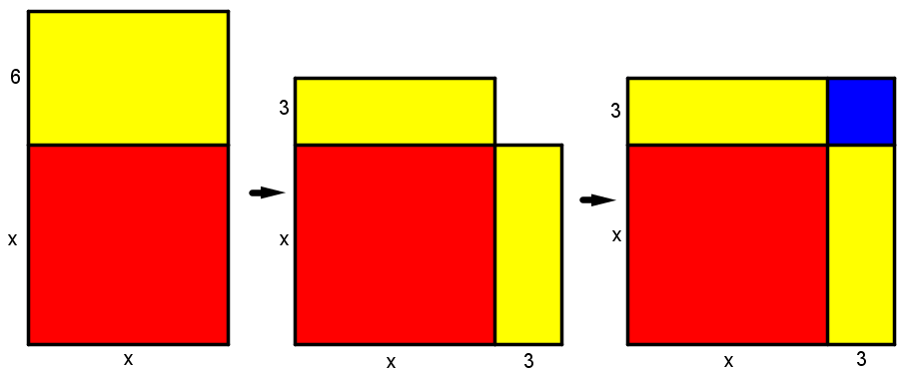

**Sample MEI resource**

‘Quadratics two-way table’ (which can be found at <https://my.integralmaths.org/integral/sow-resources.php>) is designed to make links between the algebraic and graphical representations of quadratics, paying particular attention to quadratics that might not factorise over integers but still have real roots. Students are asked to place 14 quadratics in the 12 cells of a two-way table, aiming for at least one in each cell.

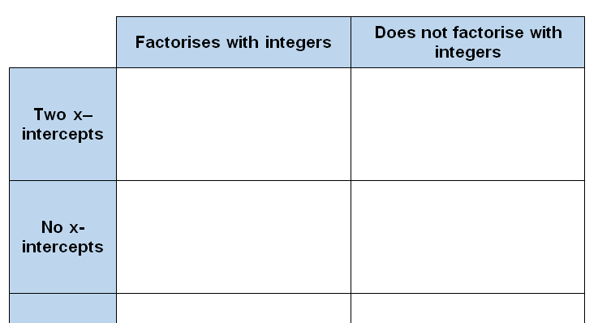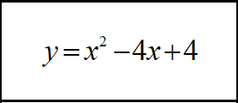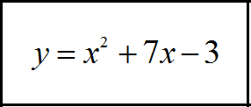

**Effective use of technology**

To encourage students to think about the links between the algebraic and graphical representations of quadratics, simply enter  into a graph plotting package and ask what will happen to the graph as the constant term, , changes. Then what would happen as the coefficient of  changes; what stays the same and what changes? Similarly, students can explore the effect of changing the coefficient of and maybe think about what happens to the vertex of the quadratic.

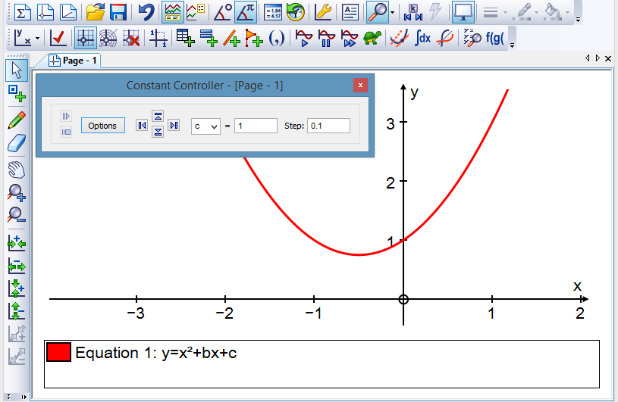

Note: screenshot above is taken from Autograph.

|  |  |
| --- | --- |
| **Quadratic functions (AS)** | **Time allocation:** |
| **Pre-requisites**   * GCSE: Manipulating quadratic expressions * GCSE: Solving quadratic equations | |
| **Links with other topics**   * Differentiation: Repeated roots and tangents; completing the square and turning points * Projectiles: the path of a projectile can be modelled by a quadratic | |
| **Questions and prompts for mathematical thinking**   * Make up three questions that show you understand three different methods for solving a quadratic equation. * Change one coefficient in  so that the  -axis is a tangent to the graph. | |
| **Opportunities for proof**   * Prove the quadratic formula * Substitute  in  and make  the subject. Prove that this gives the same roots as the quadratic formula. * Substitute  in  and factorise. Prove that the roots of this equation are the same as those given by the quadratic formula. | |
| **Common errors**   * Difficulty in completing the square when the coefficient of  is not equal to 1. * Discriminant given by  rather than * Quoting the quadratic formula incorrectly; e.g. or  instead of . * The ability to deal with negative signs when dealing with the formula. | |