**Equations and Inequalities (AS)**

|  |  |
| --- | --- |
| **B4** | Solve simultaneous equations in two variables by elimination and by substitution, including one linear and one quadratic equation |
| **B5** | Solve linear and quadratic inequalities in a single variable and interpret such inequalities graphically, including inequalities with brackets and fractions  Express solutions through correct use of ‘and’ and ‘or’, or through set notation  Represent linear and quadratic inequalities such as  and  graphically |

**Commentary**

From GCSE, students may have several methods for solving simultaneous equations. Given a free choice of method, what aspects of the two equations will indicate that one method is more straightforward than another?

When solving  by elimination students might add the equations together to get. What is happening here at a graphical level? Are the lines being ‘added’; is it possible to add lines together? It might be helpful to think in terms of a specific coordinate pair  satisfying both equations; then it is unknowns  and, rather than variables  and, that are being manipulated.

Consider the differences between the graphical representations below, both related to the quadratic. The left-hand one shows the region  and the right-hand one shows the region  which satisfies .

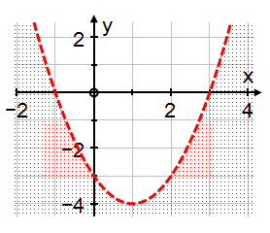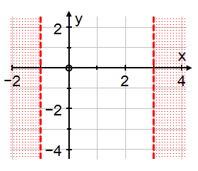

Students could be asked questions such as, ‘What is each representation showing?’, ‘What might the questions be that generate these as answers?’, and ‘What difficulties might students have in understanding the differences?’

**Sample MEI resource**

‘Categorising quadratic inequalities’ (which can be found at <https://my.integralmaths.org/integral/sow-resources.php>) is designed to encourage students to become fluent with quadratic inequalities. Once they have completed this task they might be encouraged to make up their own categories for a Venn diagram.

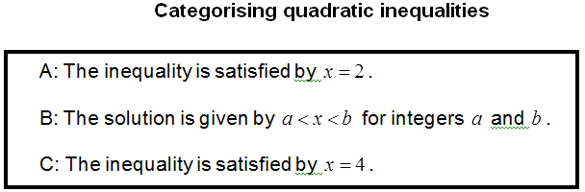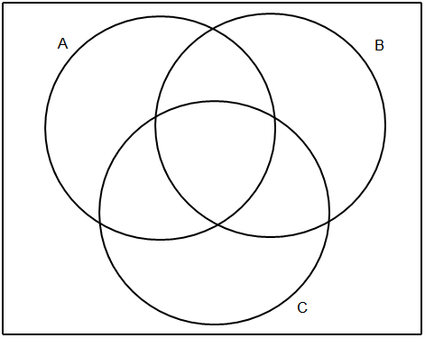

**Effective use of technology**

‘Intersection of a line and a curve’ (which can be found at [www.mei.org.uk/integrating-technology](http://www.mei.org.uk/integrating-technology)) is designed to support students in using graphing calculators with linear and quadratic simultaneous equations. It comes with questions and further tasks.

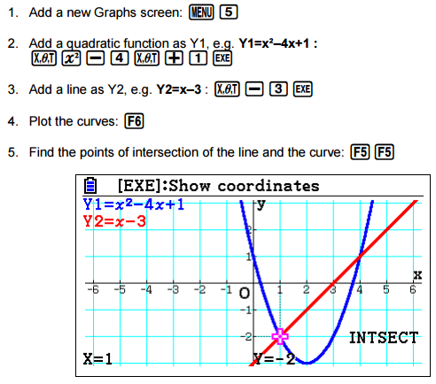

|  |  |
| --- | --- |
| **Equations and inequalities (AS)** | **Time allocation:** |
| **Pre-requisites**   * GCSE: Linear and quadratic inequalities * GCSE: Simultaneous equations | |
| **Links with other topics**   * Coordinate geometry: intersection of lines and circles * Calculus: Tangents and repeated roots | |
| **Questions and prompts for mathematical thinking**   * What questions could be used to tease out why multiplying an inequality by a negative number means you have to reverse the inequality? * Change one coefficient in the equations  so that no value ofsatisfies both. * When, . What happens to the order of inequalities for other values of? | |
| **Opportunities for proof**   * Prove that multiplying an inequality throughout by  is the same as reversing the sign. * Prove that the product of the values of  satisfying both  and  is -2 for every value of | |
| **Common errors**   * If  is between -2 and -5 writing the inequality as  rather than * Trying to combine two separate inequalities as a single expression, for example writing  and as * Thinking that  means  and * Believing that  has the same set of solutions as | |