**Coordinate geometry (AS)**

|  |  |
| --- | --- |
| **C1** | Understand and use the equation of a straight line, including the forms  and  ; gradient conditions for two straight lines to be parallel or perpendicular  Be able to use straight line models in a variety of contexts |
| **C2** | Understand and use the coordinate geometry of the circle including using the equation of a circle in the form  ; completing the square to find the centre and radius of a circle; use of the following properties:  • the angle in a semicircle is a right angle  • the perpendicular from the centre to a chord bisects the chord  • the radius of a circle at a given point on its circumference is perpendicular to the tangent to the circle at that point |

**Commentary**

Many of the aspects related to straight lines are covered at GCSE; the sample resource included below is suggested as a first lesson, in which students are given the opportunity to work collaboratively to find the answers for themselves rather than being taught all the techniques.

Students will be familiar with the formula  for a straight line but perhaps won’t really appreciate that it describes a relationship between the coordinates of every point that lies on the line; in focusing too much on  and  students can lose sight of what the equation of a line really is.

Both  and use the important idea of a variable point  on the line. For lines which do not pass through the origin, recognising  as the line passing through the points  is often helpful. Students should be thinking when each form for the equation of a line is the most appropriate to use.

Rene Descartes’ idea from the 17th century (relatively recent in the development of mathematics) in using a coordinate grid allows geometrical problems to be tackled using algebra. Drawing attention to this type of contextual background will increase students’ awareness of the ongoing development of the subject and enable them to see links between different areas.

Typically diagrams of circles show the variable point  to the right and above the centre of the circle  thereby making the equation  quite transparent using Pythagoras’s Theorem; think about this as P moves round the circle.

**Sample MEI resource**

‘Tilted Square’ (which can be found at <https://my.integralmaths.org/integral/sow-resources.php>) is intended for use in the first Coordinate geometry lesson. Designed to be a paired activity, the ideas involved are not far removed from GCSE and the activity will support students in building upon their GCSE knowledge and discovering the ideas involved at A level.

Questions for discussion with colleagues:

1. What question would you write on the blank card?
2. Which cards would be challenging for A level students with a target grade C?
3. How would you make the activity easier or harder?
4. How much lesson time would you give it?
5. What notes would you want students to make related to this activity? What support may some students need to record these notes?

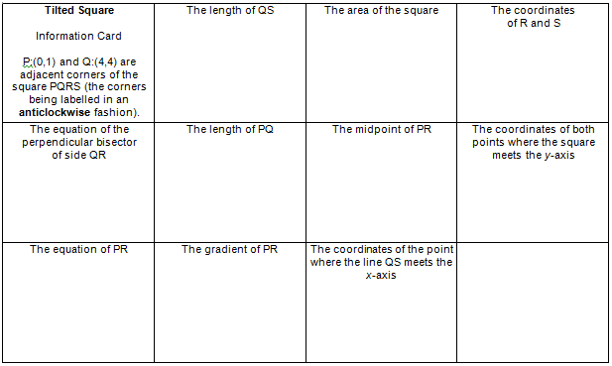

**Effective use of technology**

‘Equation of a circle’ (found at [www.mei.org.uk/integrating-technology](http://www.mei.org.uk/integrating-technology)) helps students to see the role of Pythagoras’s Theorem in the equation of a circle and to make links between the algebraic and geometric representations.

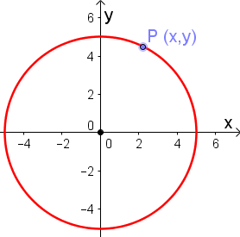 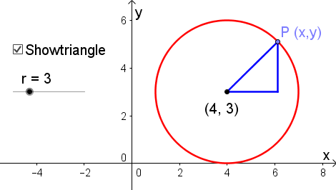

|  |  |  |  |
| --- | --- | --- | --- |
| Tell me the coordinates of any points on the circle?  Which two points have x-coordinate of 2?  What is the link between the coordinates in general - in other words, what is the equation of the circle? | | Change the radius so the resulting circle passes through the origin  As P moves around the circle to points where, for example,, why is it still true that ? | |
| **Coordinate geometry (AS)** | **Time allocation:** | |
| **Pre-requisites**   * GCSE: Pythagoras’s Theorem, straight line graphs and some circle theorems * Surds & indices: Familiarity with surds is useful * Quadratic equations and graphs: Completing the square | | |
| **Links with other topics**   * Parametric equations: In this section lines and circles are described by equations which give direct relationships between x and y; parametric equations allow us to describe lots of other curves… | | |
| **Questions and prompts for mathematical thinking**   * Make up three questions that show you understand how to choose from  when finding the equation of a straight line. * Tell me three ways, which are essentially different, of determining whether three points A, B and C lie on a straight line. * Change one number in so that the resulting circle passes through all four quadrants. | | |
| **Opportunities for proof**   * Prove that the product of the gradients of perpendicular lines (which are not parallel to the axes) is -1. * Prove that for any integers  where  the triple  is a Pythagorean triple. | | |
| **Common errors**   * When finding gradients using or  instead of * Thinking that the equation of a circle is of the form instead of * Except for the mid-point formula, all formulae should have a minus sign in the binomial term. Students using a ‘+’ instead; for example  when calculating gradients. * Difficulty dealing with fractional and/or negative gradients when finding the equations of perpendicular lines. | | |