**Trigonometry (AS)**

|  |  |
| --- | --- |
| **E1** | Understand and use the definitions of sine, cosine and tangent for all arguments; the sine and cosine rules; the area of a triangle in the form |
| **E3** | Understand and use the sine, cosine and tangent functions; their graphs, symmetries and periodicity |
| **E5** | Understand and use  Understand and use |
| **E7** | Solve simple trigonometric equations in a given interval, including quadratic equations in sin, cos and tan and equations involving multiples of the unknown angle |

**Commentary**

Most students first meet trigonometry in the context of right-angled triangles. When they go on to use the sine and cosine rules in obtuse-angled triangles they can encounter expressions such as ; these should appear meaningless if the definitions of the trig ratios are understood to be in terms of ratios of the sides of a right-angled triangle. Some teachers choose to introduce trigonometry through the unit circle centred on the origin, O; as a point, P, moves around the circle the coordinates of P are  where  is the angle between OP and the positive -axis, measured in an anticlockwise direction. Viewed in this way, values such as  have a clear meaning.

Spending time investigating the graphs of trigonometric functions, through sketching and plotting them, builds an understanding of the symmetries and periodicities in the graphs that are a direct consequence of the symmetry of the unit circle. With this understanding, students should be able to find all solutions, in a given range, of equations such as . (What are the corresponding values of  to points on the unit circle with a coordinate of 0.3?)

Encourage students to think about graphical and geometrical representations. When solving the equation it is helpful to first solve the quadratic ; in what ways are the graphs of  and  similar/different? Where can  be ‘seen’ in the unit circle? (See the two diagrams: the coordinate of the point where the line OP intersects the line . Alternatively, think about the part of the tangent to the circle at P from P to where it meets the axis.)

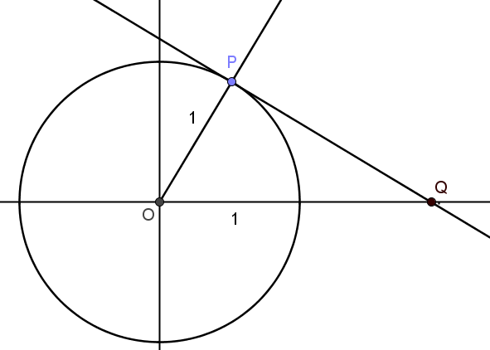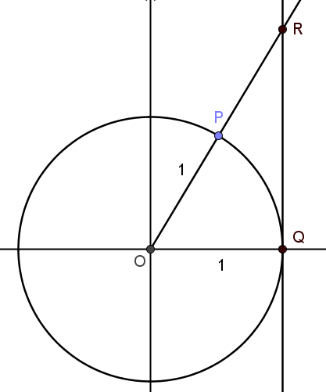

**Sample MEI resource**

‘Solving Trigonometric equations’ (which can be found at <https://my.integralmaths.org/integral/sow-resources.php>) is a card sort activity which is designed to support students in developing confidence in solving trigonometric equations which require the use of trigonometric identities. Students can work in pairs to create worked solutions, leading to opportunities to discussing links between algebraic and graphical approaches to solving trigonometric equations. There are four sets of four equations. These vary in difficulty and each set focuses on different algebraic skills or subject knowledge.



**Effective use of technology**

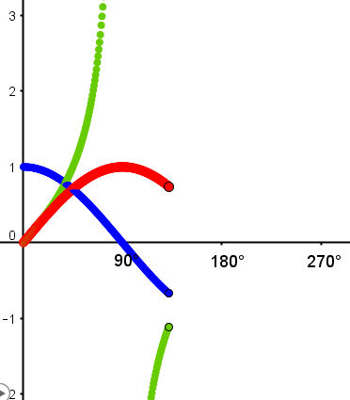‘Three trig graphs’ (which can be found at <http://www.mei.org.uk/integrating-technology>) is designed to enable students to see the link between the unit circle and the graphs of trigonometric functions.

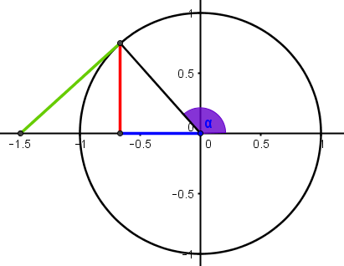

* If P is the moving point on the unit circle, why are its coordinates $\left(\cos{α}, \sin{α}\right)$?
* Explain the key features of the graphs by referring to the geometrical representation of the unit circle (e.g. why $-1<\sin{α}<1$, why $\tan{α}$ is undefined for $α=90°$, periodicity, etc)
* What can you tell me about $\sin{30°}$ and $\sin{150°}$?

|  |  |
| --- | --- |
| **Trigonometry (AS)** | **Time allocation:** |
| **Pre-requisites**   * GCSE: trigonometry (possibly students will only have experienced one particular approach or representation) * GCSE: Pythagoras’s Theorem | |
| **Links with other topics**   * Trigonometric ratios are used when resolving forces in perpendicular directions in Mechanics | |
| **Questions and prompts for mathematical thinking**   * Make up three trigonometric equations to solve that show you understand the symmetry of the three trigonometric curves. * Tell me the property that  and  must have in order that * How would you explain why there are two triangles  with the properties ? | |
| **Opportunities for proof**   * Prove the sine rule, the cosine rule and the formula  for the area of a triangle. * Prove the identities  and . | |
| **Common errors**   * Not appreciating the difference between an exact answer (as asked for in a question) and writing down a value to, say, ten decimal places from a calculator * When solving equations, not finding all of the solutions for the given range of angles * Getting the sine and cosine curves mixed up. | |