**Graphs and transformations (AS)**

|  |  |
| --- | --- |
| **B7** | Understand and use graphs of functions; sketch curves defined by simple equations including polynomials,  and (including their vertical and horizontal asymptotes); interpret algebraic solution of equations graphically; use intersection points of graphs to solve equations  Understand and use proportional relationships and their graphs |
| **B9** | Understand the effect of simple transformations on the graph of  including sketching associated graphs: |

**Commentary**

This unit builds on earlier work on polynomials and trigonometric functions. Familiarity with those is essential. The reciprocal graphs, as well as graphs of functions such as, create an opportunity to discuss asymptotes and the notion of values approaching, but not reaching, a certain value. Do students see vertical and horizontal asymptotes as essentially the same or different? A vertical asymptotes is a value of the independent variable for which the function is undefined. A horizontal asymptote is a value of the dependent variable that is being approached. How does the form in which an equation is presented to students

( or ) influence their thinking?

Look for opportunities to discuss proportionality in context. For example, how would you graph the situation described by a square-based cuboid with fixed volume; what is the relationship between the height and the length of the side of the square base?

Transformations are important because the known properties of the parent function often help us to understand properties of the family of functions which are transformations of it. For example, knowing the gradient of the curve  allows us to find the gradient of the translated curve  at a specific point without the need for the chain rule.

Some transformations seem counter intuitive; the sample resource overleaf is designed to help students understand why they behave the way they do.

**Sample MEI resource**

‘Understanding transformations’ (which can be found at <https://my.integralmaths.org/integral/sow-resources.php>) is designed to help students understand why, for example, the graph of  is a translation of one unit in the positive -direction of the graph of . By selecting a ‘non-standard’ function it draws attention to what is happening in the transformation.

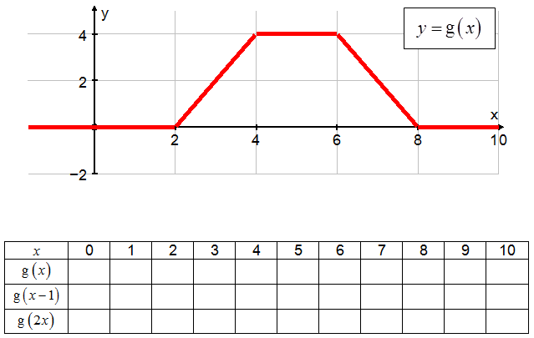

Entries can be made in the first row by reading values from the graph given. These are then used to enter the values in the other rows. Using  as an example, when  the value required is  which can be seen to equal 2 from the graph or the  row.

**Effective use of technology**

‘Transforming trig functions’ (which can be found at [www.mei.org.uk/integrating-technology](http://www.mei.org.uk/integrating-technology) ) is designed to give students insights into transformation of trig graphs. Start with and notice the rate at which the two points go round the unit circle. Note that entering a new function for  and clicking ENTER deletes the previous trace.

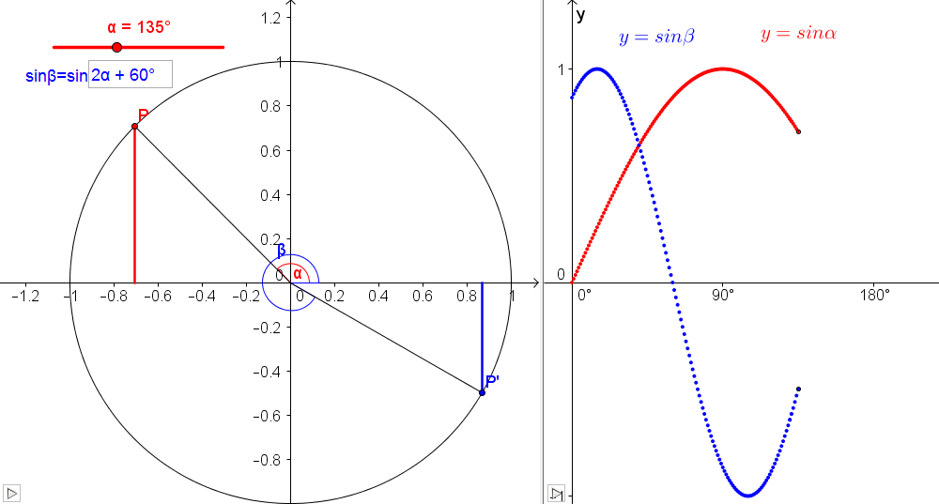

|  |  |
| --- | --- |
| **Graphs and transformations (AS)** | **Time allocation:** |
| **Pre-requisites**   * GCSE: Familiarity with reciprocal graphs and transformations of quadratic graphs * Quadratic equations and graphs: General properties of quadratic graphs * Polynomials: General properties of graphs of polynomials * Trigonometry: General properties of trigonometric graphs | |
| **Links with other topics**   * Calculus: translating a function can sometimes eliminate the need to use the chain rule or integration by substitution * Exponentials and logarithms: problems involving the laws of logarithms can sometimes be considered using transformations | |
| **Questions and prompts for mathematical thinking**   * Sketch and explain the important features of the graph * What is the same and what is different about the graphs of and ? | |
| **Opportunities for proof**   * Prove that the graph of  has rotational symmetry about the origin. | |
| **Common errors**   * Thinking  is a shift through 4 units in the positive -direction. * Thinking that  is a stretch of scale factor  in the -direction. * Knowing the difference between a sketch and a plot. In particular, where the -axis is an asymptote such as for , incorrectly continuing their ‘decreasing curve’ down below the *x*-axis. | |