**Differentiation (AS)**

|  |  |
| --- | --- |
| **G1** | **[Understand and use the derivative of as the gradient of the tangent to the graph of  at a general point (*x*, *y*);the gradient of the tangent as a limit; interpretation as a rate of change; sketching the gradient function for a given curve; second derivatives; differentiation from first principles for small positive integer powers of *x*]**  **[Understand and use the second derivative as the rate of change of gradient]** |
| **G2** | **[Differentiate *,* for rational values of *n,* and related constant multiples, sums and differences]** |
| **G3** | **[Apply differentiation to find gradients, tangents and normals*,* maxima and minima and stationary points]**,  **[Identify where functions are increasing or decreasing]** |

**Commentary**

This section is concerned with what is probably the most important concept in A level: calculus. Differentiation from first principles allows students to appreciate where the simple but extremely powerful rule ( the derivative of xn) comes from and time should certainly be devoted to it. In addition to the standard textbook cases such as and  do consider deriving the gradient function for , and the simple(?) . Differentiation from first principles is a really important idea but it can be tricky to grasp at first. You might find that students need to come back to it several times to build confidence and understanding

Be aware of the increase in conceptual demands from considering the gradient of a curve at a point to thinking about the entire gradient function.

Using calculus allows us to solve many of the great problems governed by continuously changing variables: time, temperature, movement …, from sub-atomic physics to the motion of the planets and the behaviour of the universe. Many of these require differentiation techniques met later but basic applications ( for example maximising volume) of calculus start to show how useful it is.

# This work relies heavily on what’s gone before. The maximum or minimum point on a quadratic curve can be found by completing the square, on all other polynomial curves we need differentiation and when finding the turning points on a cubic we need to solve quadratic equations. Finding the equations of the tangent and normal brings in ideas from coordinate geometry and analysing curves of the form where is negative or rational builds on students’ work on indices.

**Sample MEI resource**

‘With or without calculus?’ (which can be found at <https://my.integralmaths.org/integral/sow-resources.php>) consists of two problems which can both be solved with or without differentiation.



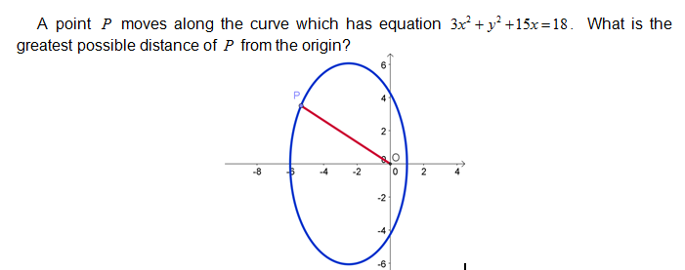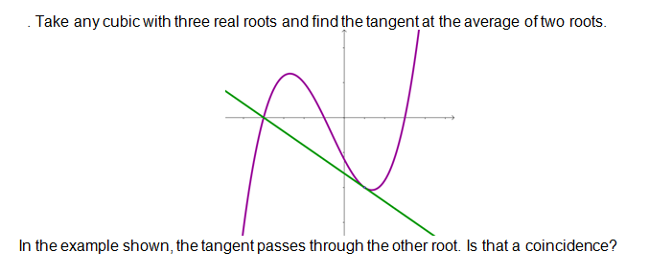

**Effective use of technology**

‘First principles’ (which can be found at [www.mei.org.uk/integrating-technology](http://www.mei.org.uk/integrating-technology)) is designed to help students understand the role of chords in differentiation from first principles. As Q is dragged along the curve towards P the gradient can be seen to approach that of the tangent to the curve at P.

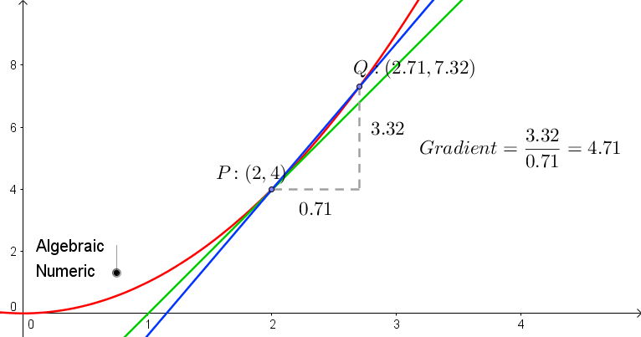

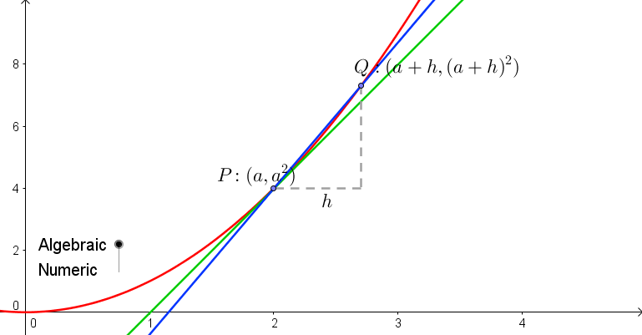

|  |  |
| --- | --- |
| **Differentiation (AS)** | **Time allocation:** |
| **Pre-requisites**   * Indices: Students need to be fluent in writing expressions such as  in index form * Equations of a straight line: knowing how to find the equation of a tangent or normal given a point on a curve and the gradient at that point | |
| **Links with other topics**   * Completing the square: another way to find turning points of quadratics * Repeated roots: A tangent to a curve can be found using the fact that there are repeated roots when solving simultaneously | |
| **Questions and prompts for mathematical thinking**   * How would you explain the role of chords in differentiation from first principles? * Is  and at a full explanation of why there is a point of inflection at  on the curve ? * Give me an example of a curve with a maximum point at | |
| **Opportunities for proof**   * Prove by first principles that  and * Prove that the rectangle enclosed by a piece of string of fixed length so that the area is maximised is the square. * Prove that the cubic  is an increasing function if and only if | |
| **Common errors**   * Assuming that at a point where  and  there must be a point of inflection * Not appreciating differentiation from first principles, especially when the question guides the student through it. * Seeing the link from , via gradients, to equations of tangents and normals. | |