**Integration (AS)**

|  |  |
| --- | --- |
| **H1** | **[Know and use the Fundamental Theorem of Calculus]** |
| **H2** | **[Integrate  (excluding *n* = -1), and related sums, differences and constant multiples ]** |
| **H3** | **[Evaluate definite integrals; use a definite integral to find the area under a curve]** |

**Commentary**

This section introduces integration as the opposite of differentiation: given  what can we deduce about the original curve? Entering, for example,  into Autograph provides a helpful visualisation: wherever the curve passes through the line  , its gradient must be 1.

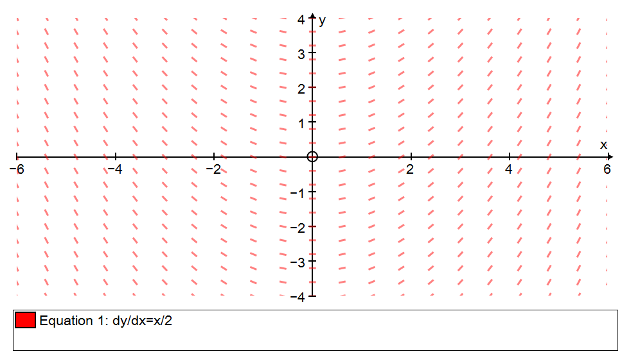

The ‘fundamental theorem of calculus’ states that applying the opposite process to differentiation to  gives the area under the curve . Students should explore a proof of this surprising ‘fundamental’ result.

Consider the definite integral  where the limits are symmetrical about . By considering the symmetrical nature of  and , this is equal to  which in turn, by symmetry, is equal to . It is interesting to think about this graphically: the shape of a general polynomial curve might appear to possess no symmetry but separating out its odd and even powers can be helpful.

**Sample MEI resource**

‘Calculus card match’ (which can be found at <https://my.integralmaths.org/integral/sow-resources.php>) requires students to use index and surd form in differentiation and integration. You might choose to replace some cards with blanks or perhaps give some students only the cards in surd form (such as  and ) leaving the students to do the intermediate conversions.

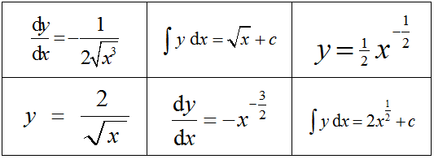

**Effective use of technology**

‘Integration and area’ (link can be found at [www.mei.org.uk/integrating-technology](http://www.mei.org.uk/integrating-technology)) is a student-centred approach to exploring integration as area.

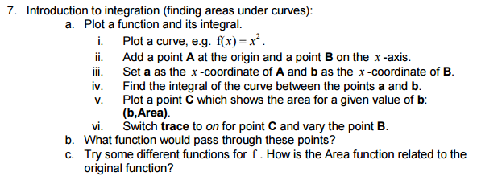

|  |  |
| --- | --- |
| **Integration (AS)** | **Time allocation:** |
| **Pre-requisites**   * AS differentiation: as with all inverse processes, fluency with the standard process helps with the reverse | |
| **Links with other topics**   * Numerical methods: the trapezium rule is used to find an approximation to the area of a region under a curve | |
| **Questions and prompts for mathematical thinking**   * Is it ever false that ? Is it ever false that ? * Give me an example of a curve for which * Make up a similar example. | |
| **Opportunities for proof**   * Prove that  for odd values of . * Prove the Fundamental Theorem of Calculus: i.e. that the reverse process of differentiation gives the area under a curve | |
| **Common errors**   * Mixing up the rules for differentiation and integration * Omitting the constant of integration, especially when finding the original equation of the curve from the given derivative. * Dealing with denominators; e.g.  as  or . * Integrating a constant  as | |