**Vectors (AS)**

|  |  |
| --- | --- |
| **J1** | **[Use vectors in two dimensions]** and in three dimensions |
| **J2** | **[Calculate the magnitude and direction of a vector and convert between component form and magnitude/direction form]** |
| **J3** | **[Add vectors diagrammatically and perform the algebraic operations of vector addition and multiplication by scalars, and understand their geometrical interpretations]** |
| **J4** | **[Understand and use position vectors; calculate the distance between two points represented by position vectors]** |
| **J5** | **[Use vectors to solve problems in pure mathematics and in context, including forces]** and kinematics |

**Commentary**

(Please note: this Commentary is the same for the vectors in AS and in A level)

Many of the basic ideas underpinning the use of vectors to solve problems will be familiar to students from GCSE. They are likely to be familiar with addition and subtraction of vectors and multiplication by a scalar; these methods will have been applied to construct geometrical arguments and proofs in two dimensions.

In this topic it is very important that students are encouraged to use terminology and notation correctly.  Vectors are usually printed in bold; when written by hand they are generally indicated using an underline in the form a. Multiples of the unit vectors $\hat{i}, \hat{j}$ and $\hat{k}$ (sometimes written with a ‘hat’ to indicate they have length 1) are used to express vectors in three dimensions.  For example, the position vector of the point with coordinates (3, 5, -2) in relation to a fixed origin would be expressed $3\hat{i}+5\hat{j}-2\hat{k}$.

For students who are also studying AS or A level Further Mathematics, it is interesting to point out that some of the modern development of vectors started around 1800 with the work of Caspar Wessel and Jean-Robert Argand in their geometrical representation of complex numbers using two dimensional vectors.

This unit focuses on the basic ideas behind vectors in 2 dimensions. Beyond AS these ideas are extended 3 dimensions and kinematics. When applying vectors to solve problems in kinematics, students need to be clear on the difference between scalar quantities such as speed, and vector quantities such as velocity.  Vector diagrams in two dimensions can provide a useful visual aid to interpret the sum of vectors representing forces as a single vector representing the resultant force.

**Sample MEI resource**

‘Properties of vectors’ (which can be found at <https://my.integralmaths.org/integral/sow-resources.php>) is designed to develop fluency with vectors. Arrange a set of given vectors so that each of the properties in the grid is satisfied by one or two vectors.

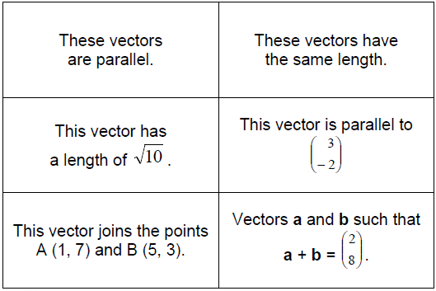

**Effective use of technology**

‘Vector addition and subtraction’ (which can be found at [www.mei.org.uk/integrating-technology](http://www.mei.org.uk/integrating-technology) ) shows the geometric representation of vector addition and subtraction. Where can you position A and B so that  is parallel to  ?... is equal to  ? …is in the same direction as ?

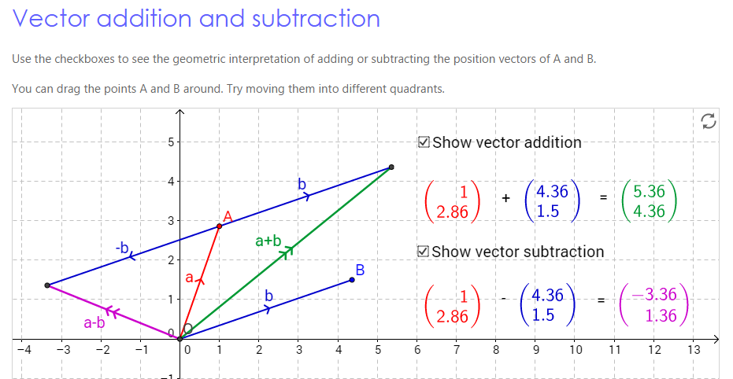

|  |  |
| --- | --- |
| **Vectors (AS and A level)** | **Time allocation:** |
| **Pre-requisites**   * Basic trigonometry: to convert between the different forms in which vectors can be expressed * Pythagoras’ Theorem to calculate distances between points. | |
| **Links with other topics**   * Polar coordinates in Further Maths: magnitude-direction form is similar to the way a point’s position is described using polar coordinates * In mechanics quantities which have both magnitude and direction, such as force and velocity, are described by vectors | |
| **Questions and prompts for mathematical thinking**   * Change one component of  so that is parallel to * Give me an example of a vector with magnitude  ….now give me an unusual example. | |
| **Opportunities for proof**   * Prove that the medians of a triangle are concurrent. * Varignon’s Theorem: For any quadrilateral, the midpoints of the sides form the vertices of a parallelogram. | |
| **Common errors**   * Taking insufficient care with notation, such as writing 5 rather than * Confusing position vectors with displacement vectors * Failure to sketch the vector particularly when bearings are involved. * Sign errors when calculating the magnitude of vectors with negative components. | |