The binomial distribution (AS)

N1 | Understand and use simple, discrete probability distributions (calculation of mean and variance of discrete random variables is excluded), including the binomial distribution, as a model; calculate probabilities using the binomial distribution

Commentary

This unit introduces the concept of a discrete random variable which is probably best done through the binomial distribution.

There is a possibility for introducing the basic ideas of this section in the Probability section by looking at simple cases such as rolling a small number of dice and counting the number of sixes rolled. See the sample MEI resource you might use in the first lesson to introduce the binomial distribution.

The obvious connection here is with the Pure topic of Binomial Expansions – in particular the expansion of ${\left(p+q\right)}^{n}$ where the term containing $p^{r}$represents the probability of $r$successes. And if $p+q=1$ then ${\left(p+q\right)}^{n}=1$ and so the sum of the probabilities is $1$.

The formula $E\left(X\right)=\sum{x_{i}p_{i}}$ is no longer part of the A level spec but students are required to know how to find the expectation for a Binomial Distribution. The calculation of the variance, $np(1-p)$, is excluded.

To encourage students to start visualising probability distributions it is worth looking at the shape of different binomial distributions and discussing how the skew depends on $p$. This should help in later topics, such as the normal distribution.

Students will be expected to have calculators that can calculate $P(X=r)$ and $P(X≤r)$ for binomial distributions. This is especially important for large values of n and statistical tables are no longer provided in examinations. For further information about the calculators which are suitable for A level Mathematics see http://www.mei.org.uk/calculators.

Sample MEI resource

‘Binomial Experiment’ (which can be found at https://my.integralmaths.org/integral/sow-resources.php) is designed for introducing the binomial distribution through a dice experiment.

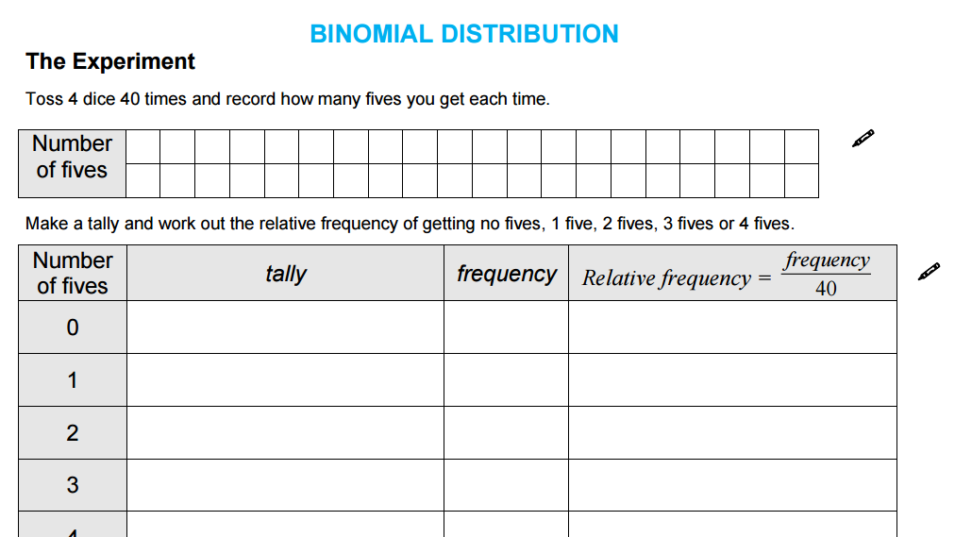

Effective use of technology

‘Falling balls’ (which can be found at www.mei.org.uk/integrating-technology) is an interactive demonstration which highlights how the distribution of binomial probabilities can be generated experimentally.

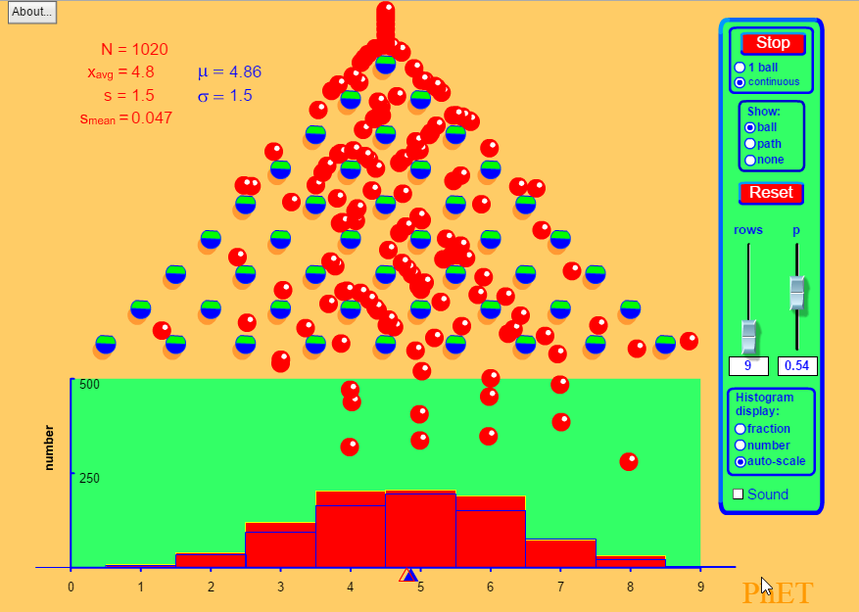

The binomial distribution | Time allocation:
Pre-requisites

- GCSE/AS: Tree Diagrams
- AS: Binomial Expansions

Links with other topics

- Hypothesis Testing: In the Hypothesis testing unit we will be able to question assertions about the value of $p$.

Questions and prompts for mathematical thinking

- Make up three questions that show you understand how the Binomial Distribution can be used in context.
- How can we be sure that $\sum{P\left(X=r\right)=1}$?

Applications and modelling

- How many dice would you need to roll to be $99\%$ certain of getting at least one six? Look into how airlines use a similar strategy when selling seats for flights – they can sell more tickets than seats because they know some people won’t turn up!

Common errors

- Confusing $P\left(X=r\right)$ and $P(X≤r)$
- Forgetting about $P\left(X=0\right)$ when calculating $P(X≤2)$
- Overstating the accuracy of a result against the context of the question.

