Kinematics (AS)

P1 | Understand and use fundamental quantities and units in the S.I. system: length, time, mass  Understand and use derived quantities and units: velocity, acceleration, force, weight, moment
Q1 | Understand and use the language of kinematics: position;  displacement; distance travelled; velocity; speed; acceleration
Q2 | Understand, use and interpret graphs in kinematics for motion in a  straight line: displacement against time and interpretation of  gradient; velocity against time and interpretation of gradient and  area under the graph
Q3 | Understand, use and derive the formulae for constant acceleration  for motion in a straight line

Commentary

Students will already be familiar with vocabulary associated with describing motion. However, it is likely that their understanding of the words, as commonly used in their colloquial language, is not necessarily the same as the definitions of the words when in a technical context. This can present something of a challenge. It is particularly important that students know the difference between a scalar quantity and a vector quantity. It is well worth taking time to ensure that students are clear about the language used to describe motion as this will underpin much of the work ahead.

Use of kinematics graphs is an extremely powerful technique that has been used in various forms at least since the time of Galileo and before the modern practice of using algebraic expressions; they can be used to give information, record information and as a scaffold to guide analysis and interpretation. Students have to understand the conventions used and be sure to use them accurately themselves.

Both the definitions and graphs involve ideas that can be (surprisingly) subtle and it is easy for students to make a false interpretation, especially if the question is phrased ambiguously.
As an example of the need for clarity, suppose Fred is on a trip from Leicester to Manchester and back which is 100 miles each way. How far is Fred from Leicester when he is half way back? Is the answer required 50 miles, 100 miles or 150 miles?

There are some things worth mentioning about the constant acceleration formulae. Of the 5 quantities involved, only one, t, is a scalar. Each of the standard 5 equations connects 4 of the 5 quantities and failure to choose the appropriate equation will lead to inefficient solutions. The processes and results have to be used with care; has a starting value, u, so gives v at any time t but the formulae for s give displacement over the elapsed time t so are not giving position (the standard formulae effectively assume the starting position is 0 when t = 0.

Sample MEI resource

‘Constant acceleration activity’ (which can be found at https://my.integralmaths.org/integral/sow-resources.php) is based on constant acceleration equations. It can be used as game of noughts and crosses. Alternatively students could be asked to find four problems with the same numerical answer.
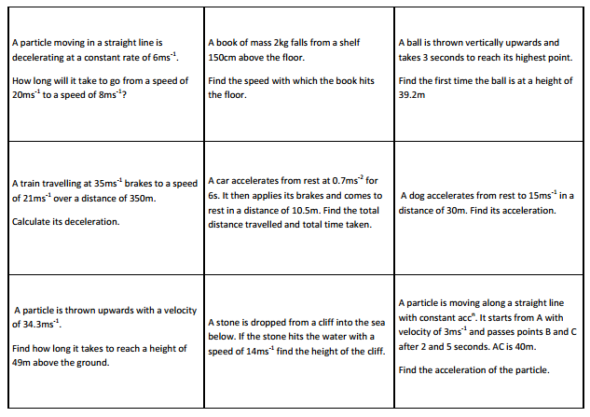

Effective use of technology

‘The Moving Man’ (which can be found at www.mei.org.uk/integrating-technology) is helpful to get students to see how a simulation can produce various graphs of motion and how they are linked.
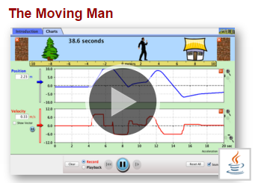

Students should be encouraged to try and simulate various displacement-time and velocity-time graphs. This website can be used to check, discuss their ideas and consider why the graphs produced may be different.

Kinematics(AS) | Time allocation:
Pre-requisites
- Know how to calculate the gradient of a line and the area of regular shapes
- Know the standard units for measuring distance, speed and acceleration
- Solving simple linear and quadratic equations

Links with other topics
- Connection to the equation of a straight line and the interpretation of the gradient.

Questions and prompts for mathematical thinking
- What is the same and what is different about the motion described by the following?

Applications and Modelling
- If you look out of a train window you will see distance markers besides the track every quarter of a mile. Take a train journey and record the time as you go past each marker. How can you use this information to draw distance-time, speed-time and acceleration-time graphs? What can you conclude about the greatest acceleration, deceleration and speed of the train?

Common Errors
- Confusing average speed with average velocity
- Assuming negative acceleration always implies deceleration; not appreciating that velocity and acceleration can have different directions
- Not establishing the relevant values, including signs, for the suvat variables.
- Using incorrect formulae; e.g..

