Forces and Newton’s laws of motion (AS)

R1 | Understand the concept of a force; understand and use Newton’s first law
R2 | Understand and use Newton’s second law for motion in a straight line (restricted to forces in two perpendicular directions or simple cases of forces given as 2-D vectors
R3 | Understand and use weight and motion in a straight line under gravity; gravitational acceleration, g, and its value in S.I. units to varying degrees of accuracy  (The inverse square law for gravitation is not required and g may be assumed to be constant, but students should be aware that g is not a universal constant but depends on location)
R4 | Understand and use Newton’s third law; equilibrium of forces on a particle and motion in a straight line ( restricted to forces in two perpendicular directions or simple cases of forces given as 2-D vectors); application to problems involving smooth pulleys and connected particles.

Commentary

This is an exciting part of the specification where students can apply the ideas developed from as early as the 17th century to many everyday scenarios. Students will learn how to combine the forces acting on a particle to obtain a single equivalent force; they will learn the condition for a system of forces applied to a particle to leave it at rest (or moving with a constant velocity); they will learn when a system of forces will cause an object to accelerate; in the latter case they will be able to determine the magnitude and direction of the acceleration

A key requirement for success is that students develop very sound understanding of the basic ideas and use efficient techniques. Many of them will have come across some of this work already but have a number of wrong ideas that have to be elicited and challenged.

It is also important that students properly understand the significance of many common modelling assumptions. For instance:

Why do we say that a string is light? This may be so that its weight need not be considered or so that it can be modelled when taut as straight even when not vertical.

Above all, whether the system of forces is in equilibrium resulting in no motion or constant velocity or there is a resultant force causing acceleration, students must always remember that the principles used are all statements about the behaviour of vector quantities.

Sample MEI resource

‘Feeling forces’ (which can be found at https://my.integralmaths.org/integral/sow-resources.php) is an excellent introduction to simple experiments in Mechanics. It gives an opportunity to confront and deal with common misconceptions about forces.

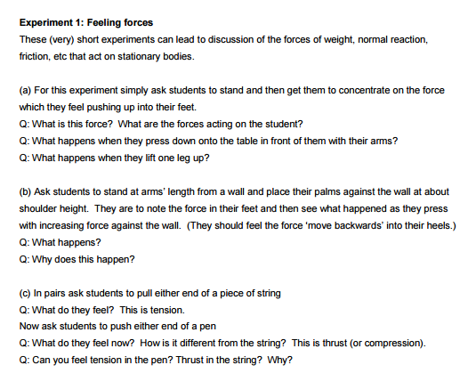

Effective use of technology
‘Interactive force diagrams’ (link can be found at www.mei.org.uk/integrating-technology) is designed to introduce and consolidate the connected particle problem.
Questions you might ask:

- What happens as the driving force increases? Will the tension increase or decrease and why?

- What will happen as the car brakes?

- What does the acceleration depend upon?

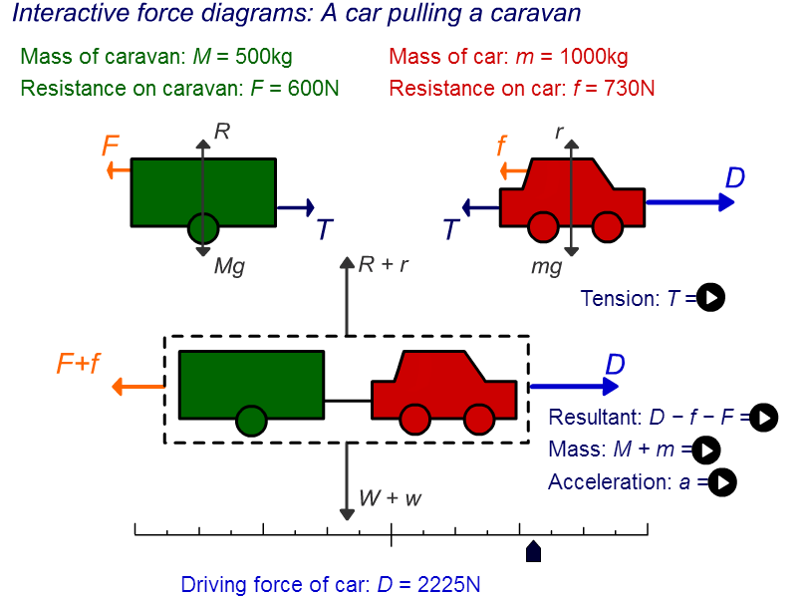

Forces and Newton’s laws of motion (AS) | Time allocation:
Pre-requisites

- No specific knowledge is needed beyond GCSE, though GCSE Science is useful
- Simple linear and simultaneous equations

Links with other topics

- Connection to Kinematics, vectors and scalars quantities

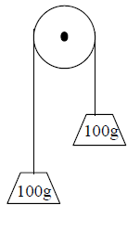
Questions and prompts for mathematical thinking

- Two identical objects are connected to the ends of a light elastic string which passes over a fixed pulley as shown. What happens if the system is released from rest?

Applications and Modelling

- A mass hangs in equilibrium on the end of a string connected to a ceiling.
What forces act on the mass?
What is meant by ‘tension in the string’?
What is meant by ‘breaking tension’?
How can you illustrate this using a practical experiment?

Common Errors

- Inconsistency in identifying which direction is positive when applying Newton’s Second Law
- Getting the correct direction for tension in a string
- Omitting a force e.g. normal reaction in a diagram or performing calculations without a sound diagram
- Given the weight, , using for a force or in Newton’s Second Law

