Variable Acceleration (AS)

Q4 | Use calculus in kinematics for motion in a straight line:

Commentary

The ways the ideas are introduced to the students in this part of the course are based on the major developments in mathematics that started in the latter part of the 17th century. For the first time, the connections between expressions in terms of time for position, velocity and acceleration could be clearly explained in general terms and clearly expressed in algebraic expressions; particularly important was the ability to represent the motion of an object moving freely under gravity.

Even in the 1D context of this specification item, the connections give a marvellously powerful calculating tool but there are some important matters that students have to understand. For instance, displacement, velocity and acceleration are all vectors and so in the 1D case students are using a vector component which is signed; this means that it is essential that students define the positive direction and use it consistently.

This work gives life to need for arbitrary constants in integration. For instance, students can easily see that many velocity functions can have the same acceleration function.

An important consequence of integration giving the signed addition of areas under a curve means that that the area under a v-t graph gives displacement, which may not be distance travelled.

Sample MEI resource

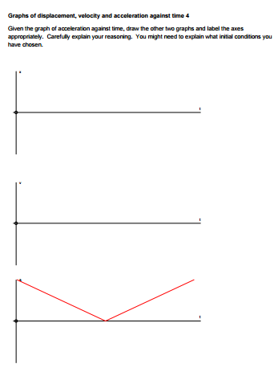
‘Motion graphs’ (which can be found at https://my.integralmaths.org/integral/sow-resources.php) is designed to explore motion graphs for variable acceleration. It consists of seven sets of motion graph axes. In the first six sets the students are given one of the graphs and have to deduce the other two.

It’s important that students are encouraged to explain their reasoning. They can also describe ‘real life’ scenarios that can be modelled by these motion graphs

Effective use of technology

‘Exam question’ (which can be found at www.mei.org.uk/integrating-technology) is designed to develop a standard exam question (OCR(MEI) Mechanics 1 Jan 2007 Question 2, which involves 1D motion described by ) to prompt further discussion and encourage students to ask additional questions.

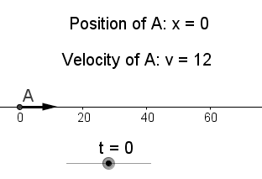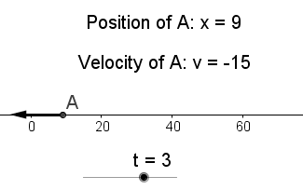

Questions to ask students:
- Describe the particle’s position for various values of t.
- What is its velocity at these times and why?
- Will the particle change direction? How do we know?
- At what times will the displacement be zero?
- What other aspects of this motion might interest us?
- Why does this question require the need for calculus?

Variable Acceleration(AS) | Time allocation:
Pre-requisites
- Confidence with simple differentiation and Integration

Links with other topics
- Direct application of Differentiation and Integration for variable acceleration problems
- Using the calculus ideas to derive the constant acceleration equations

Questions and prompts for mathematical thinking
- What questions can you ask based around this piece of information?
The acceleration of a particle P is given by a = 6t-4. Initially the particle is at rest at the origin.

Applications and Modelling
- What assumptions allow the student to create a simple model of this situation?
A student is modelling the motion of a small boat as it moves on a lake. When the speed of the boat is 12 m s^{–1}, the engine is switched off. At time t seconds later, it has a velocity of v m s^{–1} and experiences a resistance force of magnitude 20v newtons. The mass of the boat is 80 kg.

Common Errors
- Always assuming the acceleration is constant and using constant acceleration equations when the student should be using calculus.
- Forgetting the constant of integration or muddling up the constants when required to integrate twice.
- Not appreciating that the use of limits identifies the distance travelled between the two times

