**Proof**

|  |  |
| --- | --- |
| **A1** | Proof by contradiction (including proof of the irrationality of √2 and the infinity of primes, and application to unfamiliar proofs) |

**Commentary**

Proof, along with modelling and problem-solving, is one of the three *Overarching Themes* in A level Mathematics. Throughout this scheme of work, opportunities to engage students with proof have been highlighted. In addition, a range of proofs were met in the Problem Solving (AS) unit and so, by now, students should appreciate the role and importance of proof in mathematics.

Here students are introduced to proof by contradiction, sometimes called ‘Reductio ad absurdum’, in which one assumes the opposite of what is stated and show this arrives at an inconsistency. The British mathematician G. H. Hardy (1877-1947), in his book ‘A Mathematician’s Apology’ said “Reductio ad absurdum, which Euclid loved so much, is one of a mathematician's finest weapons. It is a far finer gambit than any chess play: a chess player may offer the sacrifice of a pawn or even a piece, but a mathematician offers the game.”

Students will find the ideas behind proof by contradiction difficult. Although they might be able to follow a proof, they will have problems in analysing how to decide on the way to start a proof of their own. Therefore, it is important to discuss the general structure of this type of proof and to start with simple examples, including literal ones. For example, if you told them you had discovered the “biggest number” how might they convince you otherwise? And can they do this without using proof by contradiction?

It is also important to discuss why proof by contradiction is useful and the conditions under which it can be most helpfully employed. For instance, when trying to prove a result involving infinity or irrationality it is natural to employ proof by contradiction as it is far easier to deal with finite lists and rational numbers.

Finally, it is common for students to be told that ‘prime numbers are the building blocks of mathematics’ but their KS3&4 experience probably doesn’t help them to see why. In this unit they are expected to know about prime factorisation but they probably do not have the necessary appreciation. Consider the following question and where you might address it in your teaching to help prepare students for this unit.

How many factors does the number 72 have and what do they add up to?

This table shows that there are 12 factors of (all of the form  with  and ; a link with counting combinations at GCSE) and their sum is  (a link with geometric series).

|  |  |  |  |  |
| --- | --- | --- | --- | --- |
|  | 1 | 2 |  |  |
| 1 | 1 | 2 |  |  |
| 3 | 3 |  |  |  |
|  |  |  |  |  |

**Sample MEI resource**

‘The irrationality of ’ (which can be found at <https://my.integralmaths.org/integral/sow-resources.php>) is designed to help students focus on aspects of proof by contradiction. Students need to arrange the 22 cards to make two coherent proofs. There are opportunities for critiquing and extending.

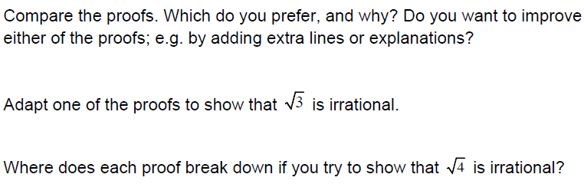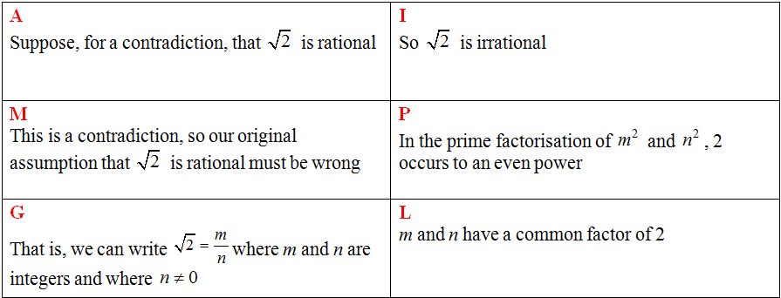

**Effective use of technology**

|  |  |
| --- | --- |
|  | Using a spreadsheet, investigate when is close to a perfect square. This will give good rational approximations to  .  For example, the three highlighted cells here show that        How good an approximation to  can students find?  What about approximations to other irrational numbers such as  and  ? |

|  |  |
| --- | --- |
| **Proof** | **Time allocation:** |
| **Pre-requisites**   * GCSE: an appreciation of prime factorisation * Problem solving (AS): this introduces other types of proof * Surds and Indices (AS): rational and irrational numbers, manipulating surds | |
| **Links with other topics**   * Surds and indices (AS): in this proof unit they now see that operations on surds resulted in a simplest form – surds cannot be expressed as fractions | |
| **Questions and prompts for mathematical thinking**   * How can we be sure that there is no biggest prime number? * Explain to me the structure of a proof by contradiction. * Think of some mathematical truths you already know that can be proved by contradiction | |
| **Opportunities for proof**   * Prove that there is no smallest positive rational number * Adapt the proof of the irrationality of  to prove the irrationality of  and of * Prove that  is irrational * Prove that the sum of a rational and an irrational number cannot be rational | |
| **Common errors**   * If a question asks for a particular result to be proved or verified then an appropriate concluding statement is usually required; a ‘tick’ or QED is insufficient. * Each line of a proof needs to be mathematically correct in order to earn full marks, and the expectations on presentation of argument are higher than at AS. * Students lose their grip on what they have assumed and what they are trying to prove part way through the proof | |