**Trigonometry**

|  |  |
| --- | --- |
| **E1** | Work with radian measure, including use for arc length and area of sector |
| **E2** | Understand and use the standard small angle approximations of sine, cosine and tangent  where  is in radians |
| **E3** | Know and use exact values of sin and cos for  and multiples thereof, and exact values of tan for and multiples thereof |

**Commentary**

Whereas degrees are an arbitrary measure of angles, radians are a more natural, mathematical choice. Radian measure is given by arc length divided by radius, i.e. a length divided by a length. This therefore gives us an angle measure in pure numbers.

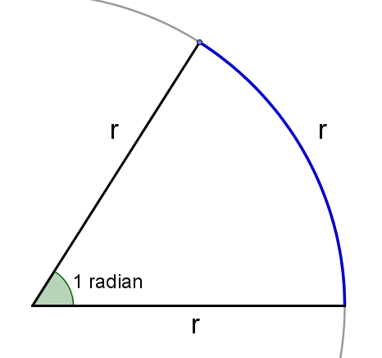

Following from the definition of radian measure,  radian is the angle subtended at the centre of a circle by an arc equal in length to the radius – an ‘equilateral slice’ (see right).

Radians are particularly important in calculus. For example, given that tangent to  at should have a gradient of , it means that the tangent should be a line making  with the -axis. For this to be the case the scales on the -axis and -axis should be the same, which is clearly not the case when working in degrees.

Students will be familiar with exact values for  and  of and from GCSE. They need to be able to use the equivalent when working in radians. Recognising and using these values is a useful skill for problem-solving.

The small angle approximations (which are the first terms in the related infinite series expansions met in Further Mathematics) allow some trigonometric equations to be approximated, near a desired root, by polynomial equations. These are more straightforward to solve. It is helpful to use a spreadsheet to see how surprisingly good these approximations are even for quite large angles (e.g. 0.3 radians is about 18°).

**Sample MEI resource**

‘Arcs and sectors’ (which can be found at <https://my.integralmaths.org/integral/sow-resources.php>) is a problem solving approach to arc lengths and areas of sector aimed at developing fluency. The lower grid includes 12 of the 13 numbers missing from the upper grid. What is the final missing number?

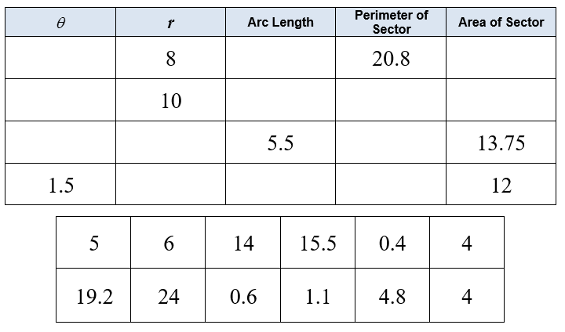

**Effective use of technology**

Using graph plotting software, draw the graphs of  and . Students can discuss extent to which it can be claimed that . The exploration can be supported by the use of a simple spreadsheet.

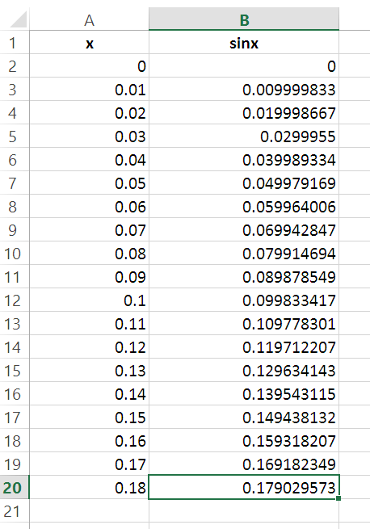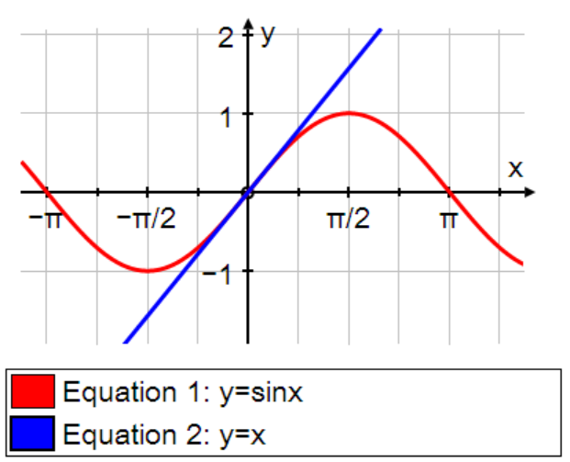Similar activities could be used for  and .

|  |  |
| --- | --- |
| **Trigonometry** | **Time allocation:** |
| **Pre-requisites**   * GCSE: exact values for special angles * GCSE: area and circumference of circles * Surds: manipulation of surds, including rationalising the denominator | |
| **Links with other topics**   * Calculus: only when measured in radians is it true that * Infinite series: when considering small angle approximations | |
| **Questions and prompts for mathematical thinking**     * How are these two diagrams related and what insight do they give? | |
| **Opportunities for proof**   * Prove the small angle approximations | |
| **Common errors**   * Confusing 1 radian with  radians * Incorrect formula for the area of a sector; e.g.  or even  instead of . * Working in degrees instead of radians when using the calculator; e.g.  whereas | |