**Functions**

|  |  |
| --- | --- |
| **B7** | Understand and use the modulus of a linear function |
| **B8** | Understand and use composite functions; inverse functions and their graphs |
| **B9** | Understand the effect of combinations of the following transformations on the graph of  including sketching associated graphs: |
| **B11** | Use of functions in modelling, including consideration of limitations and refinements of the models |

**Commentary**

Students will have used functions throughout secondary school. They will have encountered these functions in a variety of forms including function machines, an algebraic formula, a table of values, a set of ordered pairs, or a Cartesian graph. In this unit students are introduced to the definition of a function and, in particular, how functions differ from mappings. This crucial idea of each input having exactly one output gives them access to the important ideas of inverse and composite functions where the output from one function becomes the input of another.

A function is both a process (feed it an input and it will return an output) and a mathematical object in its own right:  can be sketched, differentiated, transformed, be acted on by another function , and so on. It is important for students to see this distinction and be able to move flexibly between the two notions.

A good understanding of the one-to-one nature of a function will support students in sketching graphs and understanding their properties. For example, knowing that a function must be one-to-one for an inverse to exist clarifies the definition of the functions  and , and their domains and ranges.

Similarly, being aware that a function and its inverse are images of each other, reflected in the line $y=x$, will support students’ recall of the graphs of the functions  and  and the relationship between these two inverse functions.

**Sample MEI resource**

‘Domain-Range grid’ (which can be found at <https://my.integralmaths.org/integral/sow-resources.php>) is designed to encourage students to think about the natural domains and ranges of all the functions they have met. Can they find a function for each domain-range pair?

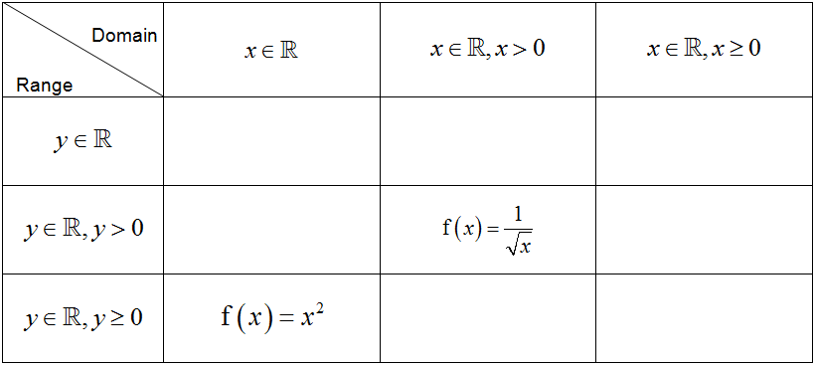

**Effective use of technology**

‘Composite function graph’ (which can be found at [www.mei.org.uk/integrating-technology](http://www.mei.org.uk/integrating-technology)) is designed to give students graphical insights into composite functions. As M: moves along the curve , what are the coordinates of N, P and Q? What is the function whose graph is being traced out by Q?

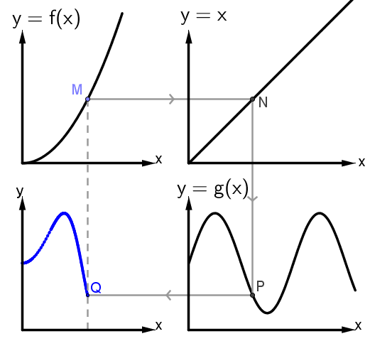

What can you say about the domain of the resulting function in relation to that of ?

What can you say about the range of the resulting function in relation to that of ?

|  |  |
| --- | --- |
| **Functions** | **Time allocation:** |
| **Pre-requisites**   * GCSE: Higher tier includes function notation, composites and inverses * Graphs and transformations AS: a knowledge of transformations * Logarithms and exponential AS: being able to sketch the graphs | |
| **Links with other topics**   * Parametric equations: here functions map a real number into a point in the plane, for example . * Trigonometry: Restricting the domain of the trig functions for the inverses to exist | |
| **Questions and prompts for mathematical thinking**   * For any function,, is it ever false that roots of the equation  lie on the line ? * What is the same and what is different about the equations  and ? * Give me three different examples of functions for which  for all  in the domain. What is the geometrical significance of this property? | |
| **Opportunities for proof**   * Prove that the graphs of a function and its inverse are reflections in the line * Prove that if the graphs of  and  have rotational symmetry about the origin then so has the graph of . | |
| **Common errors**   * Confusing  and, and more generally * Not restricting the original domain to a one-to-one mapping to establish the inverse function; e.g. in sketching | |