**Differentiation**

|  |  |
| --- | --- |
| **G1** | ~~Understand and use the derivative of sin~~*~~x~~* ~~and cos~~*~~x~~*  Understand and use  the second derivative in connection to convex and concave sections of curves and points of inflection |
| **G3** | Apply differentiation to find points of inflection |
| **G4** | Differentiate using the product rule, the quotient rule and the chain rule, including problems involving connected rates of change and inverse functions |

**Commentary**

The tangent, as an approximation to a curve, can easily be visualised; in this way students can appreciate what the first derivative is. The second derivative, the rate of change of the gradient, is more difficult to visualise. Technology has an important role to play here; using graphing software, as a point and the related tangent move along a curve, students can appreciate the rate at which the gradient is changing and they can graph both the first and second derivatives.

Also using graphing software, students can see the change in behaviour of the tangent as it passes through a point of inflection. Since many A level students will be learning to drive, you might want to discuss points of inflection in terms of when they change from ‘left hand down’ to ‘right hand down’ (or vice versa) when steering.

It is helpful to make links between the chain rule (or ‘function of a function’ rule) and composite functions. For example, if  and , as  increases from 0 to 3, how quickly is  changing and then how quickly is  changing?

The product rule can be proved from first principles: . In turn, the quotient rule for  can be proved by using the product rule on . How will your students engage with the proofs of the three rules in this unit?

**Sample MEI resource**

‘Tangents and Normals’ (which can be found at <https://my.integralmaths.org/integral/sow-resources.php>) uses the chain, product and quotient rules in finding equations of tangents and normals. Students need to arrange given steps to form solutions to two problems, inserting missing steps and writing notes of explanation.

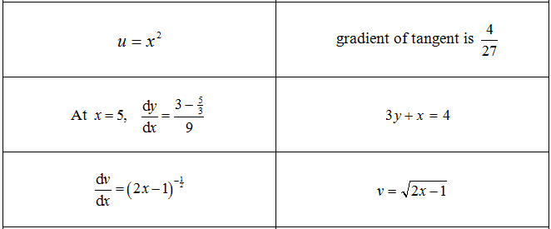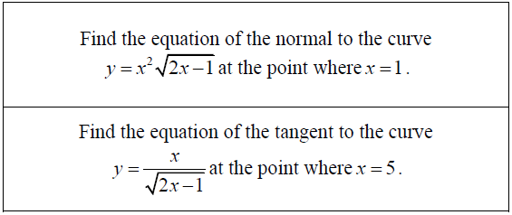

**Effective use of technology**

‘Rectangles in an ellipse’ (which can be found at [www.mei.org.uk/integrating-technology](http://www.mei.org.uk/integrating-technology)) is a GeoGebra file which graphs the areas of rectangles with vertices on the ellipse with equation . Where should point A be to maximise the area? To answer this question requires the chain and product rules.

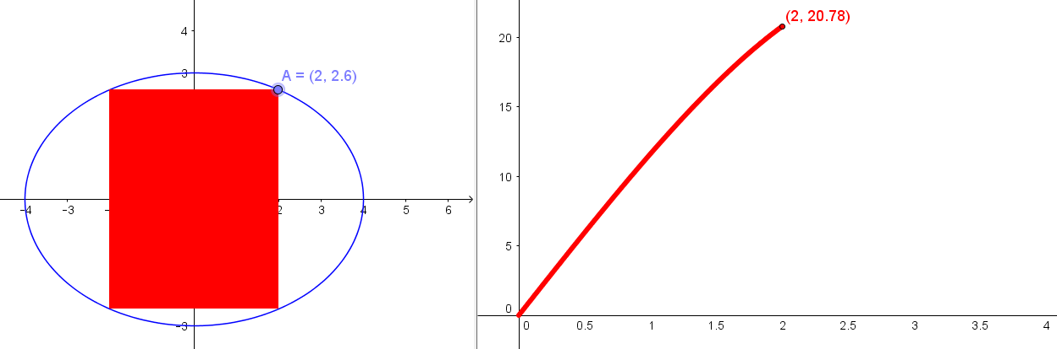

What about the position of point A for other ellipses ?

|  |  |
| --- | --- |
| **Differentiation** | **Time allocation:** |
| **Pre-requisites**   * Differentiation (AS): using differentiation techniques in problems * Functions: composite functions | |
| **Links with other topics**   * Functions: the chain rule is used to differentiate composite functions | |
| **Questions and prompts for mathematical thinking**   * Make up one question in which you need to use both the product rule and the chain rule * Why is the chain rule sometimes called the function of a function rule? | |
| **Opportunities for proof**   * Prove that every cubic curve has rotational symmetry about its point of inflection * Using , prove the product rule from first principles * Using the product rule on , prove the quotient rule formula for | |
| **Common errors**   * Failing to be clear which variable is being differentiated and with respect to which other variable and generally using  as a universal notation for “the differential coefficient of” * Assuming a more simple model for product and chain rule (e.g. just the product of differentials) * Difficulty recognising products and composite functions | |