**Trigonometric Functions**

|  |  |
| --- | --- |
| **E4** | Understand and use the definitions of secant, cosecant and cotangent and of arcsin, arccos and arctan; their relationships to sine, cosine and tangent; understanding of their graphs; their ranges and domains |
| **E5** | Understand and use  and |

**Commentary**

In this unit students will encounter the ‘other three’ trigonometric functions – secant, cosecant and cotangent. These can be considered as the remaining ratios created from pairs of ‘opposite, adjacent and hypotenuse’ and hence link back to what many students encounter at GCSE.

It is natural to focus on reciprocal pairs (sine-cosecant, cosine-secant, tangent-cotangent) but the real inverse pairs are sine-cosine, secant-cosecant, tangent-cotangent. For example cosine θ is sine of the complementary angle to θ, or  . The technology resource described below will help students to see the connections between different trigonometric functions.

Students should become familiar with the graphs of the trigonometric functions and be able to identify the key features. Reasoning graphically can give insight into many problems they encounter.

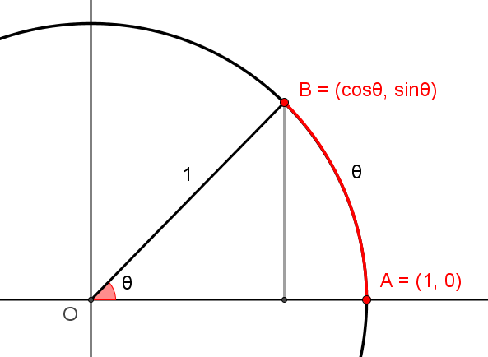

The geometry explains the terminology arcsine and arccosine. As seen in the image to the right, on a unit circle, centre O, the arc length from A to B is  (measured in radians). This means that  is the length of the arc AB. Similarly with .

**Sample MEI resource**

‘Sometimes, Always, Never True Trigonometric Statements’ (which can be found at <https://my.integralmaths.org/integral/sow-resources.php>) is an opportunity for students to discuss a series of statements in order to conclude which values of  they are true for. A key element of the task is justifying their decisions. There is an opportunity to use graph plotting software to aid this reasoning process.

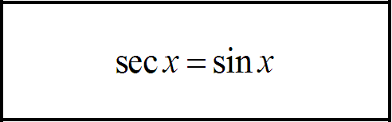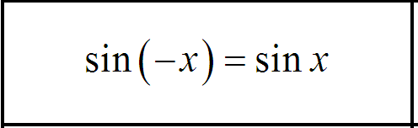

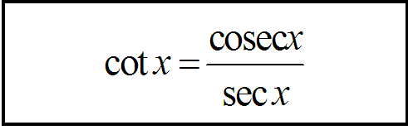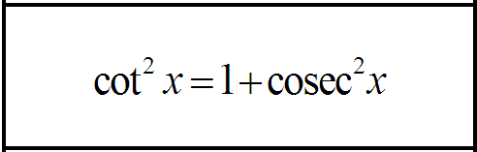

**Effective use of technology**

‘Six Trigonometric Functions’ (which can be found at <http://www.mei.org.uk/integrating-technology>) is designed to help students see the trig functions in relation to the unit circle. Once they have matched the functions with lengths, they can visualise how each changes as  increases from  to . Many identities can be formed by applying Pythagoras’s Theorem to each of the five right-angled triangles, or by using properties of similar triangles, or by viewing the area of triangle, such as ADE, in more than one way.

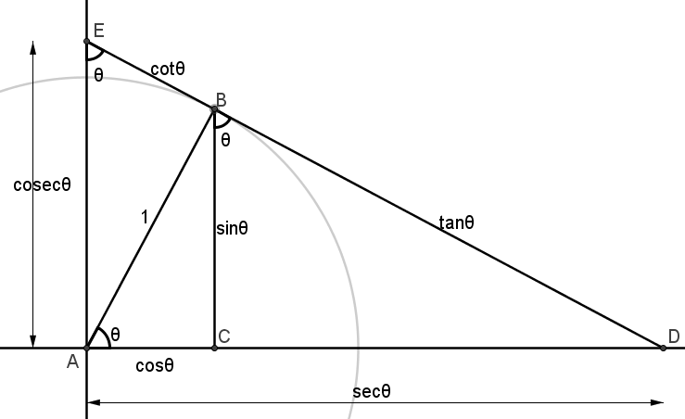

|  |  |
| --- | --- |
| **Trigonometry Functions** | **Time allocation:** |
| **Pre-requisites**   * GCSE: basic trigonometric ratios * Trigonometry: previous units on trigonometry | |
| **Links with other topics**   * Calculus: use of trigonometric identities for integration | |
| **Questions and prompts for mathematical thinking**   * Give me two examples of trig functions with asymptotes at . * How would you explain why ? | |
| **Opportunities for proof**   * Prove the trig identities  and  using Pythagoras’s Theorem | |
| **Common errors**   * Thinking of inverse trigonometric functions as reciprocal trigonometric functions * Using incorrect formulae; e.g. using  instead of | |