**Algebra**

|  |  |
| --- | --- |
| **B6** | Simplify rational expressions including by factorising and cancelling, and algebraic division (by linear expressions only) |
| **B10** | Decompose rational functions into partial fractions (denominators not more complicated than squared linear terms and with no more than 3 terms, numerators constant or linear) |
| **D1** | Extend [the binomial expansion] to any rational *n*, including its use for approximation; be aware that the expansion is valid for  . (proof not required) |

**Commentary**

When studying infinite geometric series we find that , for , and substituting  gives the result . Clearly, expressions of the form  can be expressed as infinite geometric series, over a certain domain; are there other values of  for which  can be expressed as an infinite (although not geometric) series? Before looking at the binomial theorem, you might like to explore this idea with your students. For example, differentiating throughout  with respect to  leads to an infinite series for . Similarly, expanding  and finding the values the coefficients must take in order to make it converge to, say, , gives insight into the infinite series for . Using a graph plotter to examine what happens when a sequence of plots is produced, each including one more term of the series than the last, easily allows students to observe the series wrap themselves around the graph of the original function and appreciate convergence over the corresponding domain.

The proof of the binomial theorem is not included in A level Maths but Further Maths students could engage with this when studying Maclaurin series.

At A level, partial fractions are useful in rewriting certain algebraic fractions in a more useful form, either to integrate or to express as an infinite series. Both of these are concerned with continuous functions. You might want to show your students how partial fractions can be used to evaluate some infinite series. For example, the value of  is not obvious but using partial fractions this can be seen to be the same as .

**Sample MEI resource**

‘Correct Me’ (which can be found at <https://my.integralmaths.org/integral/sow-resources.php>) contains many of the common errors that are made when using the binomial theorem. Students should mark the answers carefully (only two of the six are shown below), correcting all the mistakes and adding comments, explaining what the errors are.

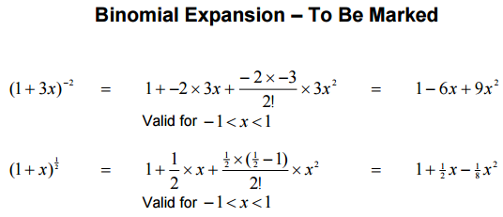

**Effective use of technology**

Using graph plotting software, draw the graphs of  and the first few terms of its binomial expansion:  . As more terms are included watch the approximation wrap itself around the original curve over the domain of convergence.

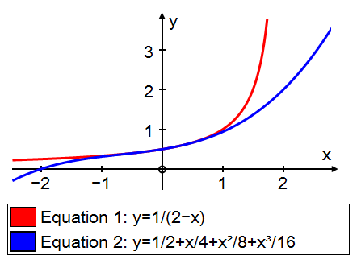 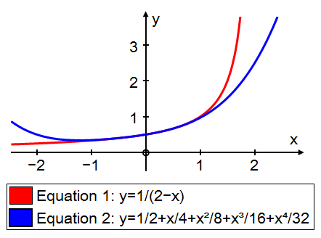

|  |  |
| --- | --- |
| **Algebra** | **Time allocation:** |
| **Pre-requisites**   * GCSE: Simplifying algebraic fractions * The Binomial Expansion: this looks at the finite expansion of , where  is a positive integer. | |
| **Links with other topics**   * Infinite geometric series: ; geometric series start from the left hand side, in this unit we start with the right hand side. * Polynomials: In this unit we see that over a certain domain all functions of the form  can be approximated by polynomials. * Integration: partial fractions transforms some expressions into a form that allows us to integrate them | |
| **Questions and prompts for mathematical thinking**   * Explain how the binomial theorem can be used to find approximations of square roots. * Give me an example of a binomial expansion where the expansion is valid only for . * Make up three questions that show you understand different applications of partial fractions. | |
| **Opportunities for proof**   * Using the binomial expansion of , prove that . Can you find a better rational approximation for ? | |
| **Common errors**   * Expanding  as if  had the value 1. * Mistakes over signs in expanding, for example, * Missing out partial fractions when there is a repeated factor * Omitting the ‘validity term’ or stating it incorrectly. | |