**Trigonometric Identities**

|  |  |
| --- | --- |
| **E6** | Understand and use double angle formulae; use of formulae for  and ; understand geometrical proofs of these formulae.  Understand and use expressions for  in the equivalent forms of  or |
| **E8** | Construct proofs involving trigonometric functions and identities |

**Commentary**

If the values of  and  are known, how could the values of  and  be evaluated? How can the diagram below, which shows two copies of the same isosceles triangle, help in answering this question?

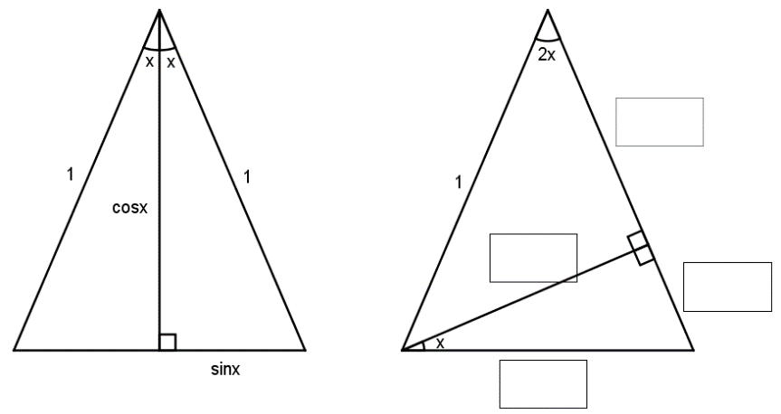

The double angle formulae can be derived ‘for free’ from the compound angle formulae by setting . However, is there an argument for tackling the double angle formulae first? And then how can the idea above be adapted to prove the compound angle formulae?

Often the natural reading of  is to immediately think of the compound angle formulae. Similarly, the natural reading of  is to think of transformations of graphs. What insights into graph transformations can students get from the compound angle formulae?

The process of completing the square expresses a general quadratic in the helpful form in which the variable appears only once and consequently the quadratic curve can be seen to be a transformation of . In this a similar idea is met with expressions of the form  where expressing them as  shows that they are simply transformations of  . The ways in which sine curves interact like this is at the heart of many natural phenomena related to waves.

**Sample MEI resource**

‘Three challenge questions’ (which can be found at <https://my.integralmaths.org/integral/sow-resources.php>) uses the compound angle formulae in a problem solving context.

|  |  |
| --- | --- |
|  |  |

**Effective use of technology**

Using a graph plotter, investigate the curves of the form  . Are these transformations of ?

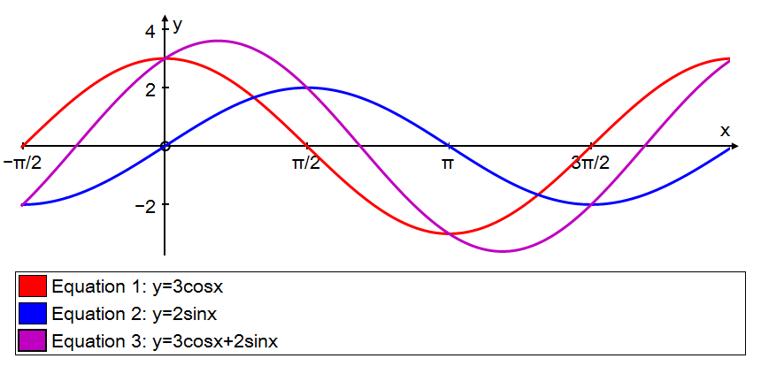

Technology allows students to cojecture that the amplitude is and this then leads to the result:

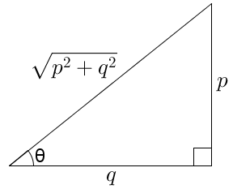

|  |  |
| --- | --- |
| **Trigonometric Identities** | **Time allocation:** |
| **Pre-requisites**   * Trigonometry: the earlier Trigonometry (AS & A level) and Trigonometric Functions units | |
| **Links with other topics**   * Transformation of graphs:  is a transformation of  (since it is the same as ) | |
| **Questions and prompts for mathematical thinking**   * Find two ways of solving the equation * Explain connections between the graph of  and the graph of . | |
| **Opportunities for proof**   * Prove  from a diagram * and  are the angles of a non right-angled triangle. Prove that . | |
| **Common errors**   * Not knowing the formulae: an over-reliance on the formulae booklet and so not appreciating that, for example,  can be written in a more helpful form. * Mis-use of the principle angle e.g.  then not proceeding to give the angles in the correct range. | |