**Further Differentiation**

|  |  |
| --- | --- |
| **G1** | Understand and use the derivative of  and  ~~Understand and use  the second derivative in connection to convex and concave sections of curves and points of inflection~~ |
| **G2** | Differentiateand, *, ,* and related sums, differences and constant multiples  Understand and use the derivative of |
| **G5** | Differentiate simple functions and relations defined implicitly ~~or parametrically~~, for first derivative only |

**Commentary**

As with all differentiation, prior to carrying out differentials students should consider the gradient by first looking at the graph of the function and then the gradient function. Technology has an important role to play in this unit. Using graphing software, students can see that the graph of the gradient function of  is similar to the function itself, and that when  the function and its gradient function coincide, thus illustrating . Exploring gradient functions of ,  and so on then reinforces the chain rule. Similarly they can find the gradient functions of  and  and appreciate the importance of radians in the final two.

How will your students engage with the proofs of the results in this unit? Will they be able to apply the first principle rules that they used in their first differentiation work?

It is important not to perform differentiation in isolation. For example, when asked to differentiate , students might first attempt to sketch the curve (thinking about symmetry, behaviour near the origin, and relationship to the lines  and ) and then think what differentiation tells them about the turning points and the points where the curve touches the line  .

This unit represents almost the end of the road for differentiation but for integration the journey has hardly begun!

**Sample MEI resource**

‘Product and Quotient Rule Dominoes’ (which can be found at <https://my.integralmaths.org/integral/sow-resources.php>) is a set of 20 dominoes which provides students with an opportunity to practise the product and quotient rules with trigonometric, exponential and logarithmic functions and to check their answers. Students should be encouraged to plot the graphs to help them make links between the calculus and the graphical forms.

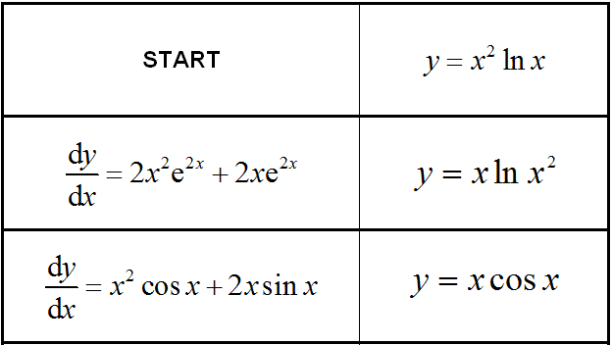

**Effective use of technology**

Using the degrees mode angle-degrees 24 h p in Autograph, plot the function , predict its gradient function and then plot this equ-gradient 24 h p. Use the constant controller **constantcon 24 h p** to see how the gradient function changes with . For what value of  does the gradient function have amplitude 1? What is the link with radian measure?

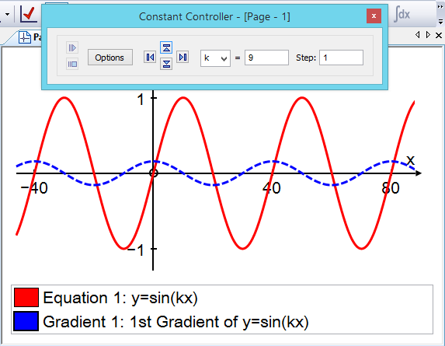

|  |  |
| --- | --- |
| **Further differentiation** | **Time allocation:** |
| **Pre-requisites**   * Differentiation (AS): using differentiation techniques in problems * Differentiation: familiarity with the chain, product and quotient rules * The trigonometric, exponential and natural logarithm functions | |
| **Links with other topics**   * The binomial expansion: explore the implicit curve | |
| **Questions and prompts for mathematical thinking**   * Tell me two ways of finding the gradient of the tangent to the circle  at the point . * How would you explain why  is only true if  is measured in radians? * Why do  all give the same answer? | |
| **Opportunities for proof**   * Prove that the graphs of  and  are perpendicular at all crossing points. * Prove | |
| **Common errors**   * Errors with signs in and * Using the incorrect formula for the quotient rule e.g. using a ‘+’ in the numerator. * Overlooking the need for the chain rule for some terms when differentiating a product or quotient. | |