**Integration (A level)**

|  |  |
| --- | --- |
| **H2** | Integrate **,** , *,* and related sums, differences and constant multiples |
| **H3** | Use a definite integral to find the area between two curves |
| **H4** | Understand and use integration as the limit of a sum |
| **H5** | Carry out simple cases of integration by substitution and integration by parts; understand these methods as the inverse processes of the chain and product rules respectively  (Integration by substitution includes finding a suitable substitution and is limited to cases where one substitution will lead to a function which can be integrated; integration by parts includes more than one application of the method but excludes reduction formulae) |
| **H6** | Integrate using partial fractions that are linear in the denominator |

**Commentary**

It is helpful to introduce the two new rules for integration as the reverse of two of the rules met in the differentiation unit: the reverse of the chain rule is integration by substitution and the reverse of the product rule is integration by parts.

Students now know quite a lot of techniques for integration. Which of these can they do and which need more advanced techniques?



It is important not to perform integration in isolation. For example, when asked to evaluate  students might first attempt to sketch the curve, thinking about symmetry, in order to appreciate that they could instead simply evaluate . Similarly, what does  look like (and can students find two ways of integrating this function?)

When using substitution to evaluate definite integrals, it is interesting to look at the shape of the region under the original curve ( against ) and compare it with the region under the curve after substitution ( against ). Although the areas are the same, the shapes are often surprisingly very different. Similarly the shape of the region between two curves  and  can be very different from the shape of the region  and yet the areas are the same.

**Sample MEI resource**

‘Methods of Integration’ (which can be found at <https://my.integralmaths.org/integral/sow-resources.php>) is a group activity deciding on the method required to integrate each of a range of functions.

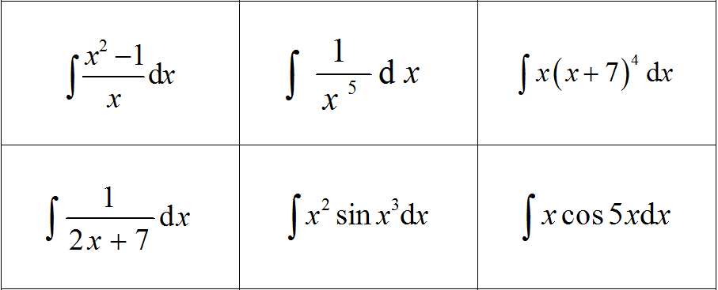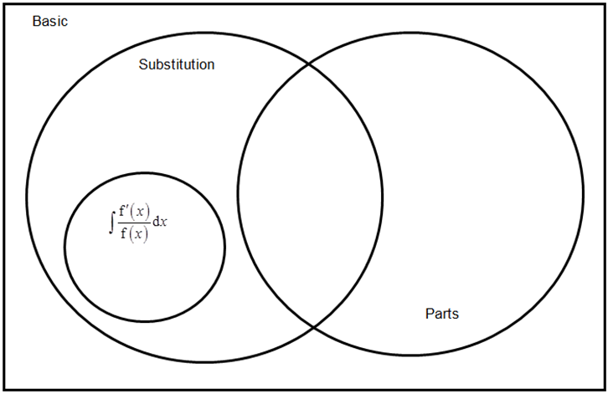

**Effective use of technology**

‘Area under 1/x and the natural logarithm function’ (which can be found at [www.mei.org.uk/integrating-technology](http://www.mei.org.uk/integrating-technology) ) provides a numerical way of illustrating how the area function  has logarithmic properties, such as .

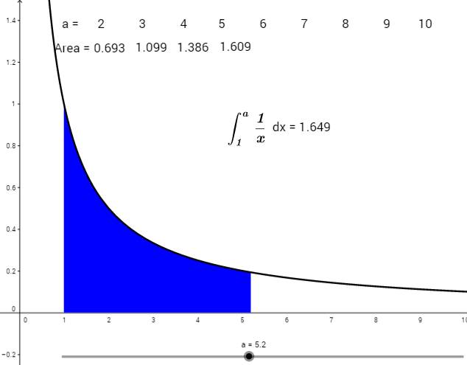

|  |  |
| --- | --- |
| **Integration (A level)** | **Time allocation:** |
| **Pre-requisites**   * Differentiation: knowing the derivatives of polynomial, trigonometric, exponential and logarithmic functions * Integration (AS): definite and indefinite integrals * Algebra: writing algebraic fractions in partial fraction form | |
| **Links with other topics**   * Trigonometric identities: Knowing  how can you evaluate  without using integration techniques? * Functions: in terms of the symmetry possessed by the constituent functions, explain why  is the same as | |
| **Questions and prompts for mathematical thinking**   * Show me two ways of finding the indefinite integral * Give me an example of an integral which you could easily solve after making the substitution . * Is substitution a useful technique for finding ? | |
| **Opportunities for proof**   * Starting from the product rule for differentiation, prove | |
| **Common errors**   * When using integration by substitution, forgetting to change the limits in definite integrals * Inability to select the appropriate method (parts, substitution) for integrating a function * The omission of  in the student’s original integrand and hence the failure to substitute for . * ‘Chain rule integration’; e.g.  or  or | |