**Parametric Equations**

|  |  |
| --- | --- |
| **C3** | Understand and use the parametric equations of curves and conversion between Cartesian and parametric forms |
| **C4** | Use parametric equations in modelling in a variety of contexts |
| **G5** | Differentiate simple functions and relations defined […] parametrically, for first derivative only |

**Commentary**

Some problems are easier to analyse using a parametric, rather than a Cartesian, approach. For example, a white spot is marked on a car tyre; what is the equation of the path of this spot as the car drives along a flat road? Similarly in Mechanics it is easier to describe, using Newton’s Laws, the  and  coordinates of a projectile independently in terms of the parameter  (for time) rather than trying to establish a Cartesian equation.

Students need to think carefully when eliminating the parameter to convert parametric equations into Cartesian equations. For example, you might want to look to see if students notice that, since  for all values of , the graph of  will not be the same as . A graph plotter is useful here, to highlight the difference, and elsewhere to see the beauty of some parametric curves: for example,  as  varies.

Students often write, erroneously,  when the function being differentiated isn’t  and/or the variable isn’t . Parametric equations force them to think more carefully: what precisely do  and  represent? And why are  linked via the chain rule, which usually involves a substitution?

**Sample MEI resource**

‘Parametric cards’ (which can be found at <https://my.integralmaths.org/integral/sow-resources.php>);12 of the 42 cards are shown below) requires students to match pairs of the form  which need to satisfy conditions related to the gradient of the resulting curve and the point it passes through when  .

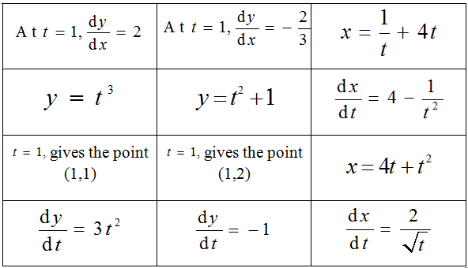

**Effective use of technology**

‘Introducing parametric curves’ (which can be found at [www.mei.org.uk/integrating-technology](http://www.mei.org.uk/integrating-technology)) is designed to encourage students to think about features of the separate cartesian curves  and  to understand the curve with parametric equations .

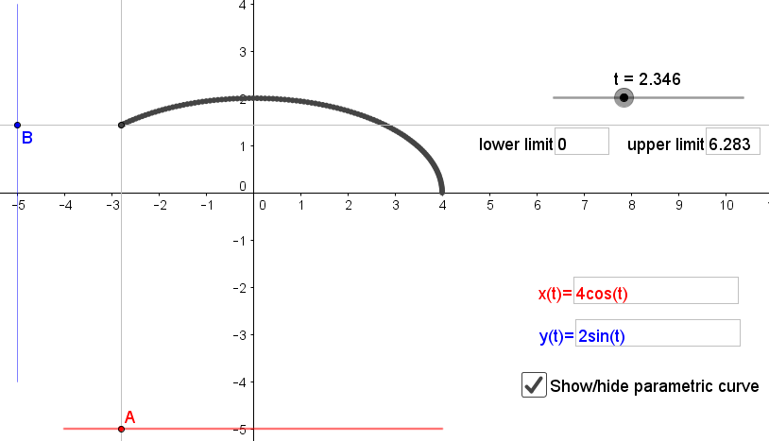

|  |  |
| --- | --- |
| **Parametric Equations** | **Time allocation:** |
| **Pre-requisites**   * Differentiation: finding tangents to curves defined parametrically involves calculus techniques * Trigonometry: parametric equations often involve trigonometric functions | |
| **Links with other topics**   * Functions: in the Functions unit, all functions had domain and range as subsets of the real numbers but here the range is usually 2D space; for example, * Projectiles: the path of a projectile is modelled using parametric equations | |
| **Questions and prompts for mathematical thinking**   * What’s the same and what’s different about the curve with cartesian equation  and the curve with parametric equations ? * Describe which features of the parametric equations  make it non-differentiable at the point corresponding to . * Give me an example of parametric equations of a curve which has a vertical asymptote. | |
| **Opportunities for proof**   * For the curve with parametric equations  prove that if the point with coordinates  is on the curve then so is the point with coordinates . What does this tell you about the curve? | |
| **Common errors** Inability to eliminate the parameter from parametric equations due to not being fluent in the use of trigonometric identities.  * Not being able to simplify dy/dx once found (usually due to inefficient use of algebra techniques) * Realising that the independent variable must use radian measure instead of degrees when finding relevant coordinates. | |