Vectors

J1 | [Use vectors in two dimensions] and in three dimensions
J2 | [Calculate the magnitude and direction of a vector and convert between component form and magnitude/direction form]
J3 | [Add vectors diagrammatically and perform the algebraic operations of vector addition and multiplication by scalars, and understand their geometrical interpretations]
J4 | [Understand and use position vectors; calculate the distance between two points represented by position vectors]
J5 | [Use vectors to solve problems in pure mathematics and in context, including forces] and kinematics

Commentary

(Please note: this Commentary is the same for the vectors units in AS and in A level)

Many of the basic ideas underpinning the use of vectors to solve problems will be familiar to students from GCSE. They are likely to be familiar with addition and subtraction of vectors and multiplication by a scalar; these methods will have been applied to construct geometrical arguments and proofs in two dimensions.

In this topic it is very important that students are encouraged to use terminology and notation correctly. Vectors are usually printed in bold; when written by hand they are generally indicated using an underline in the form a. Multiples of the unit vectors $\hat{i}, \hat{j}$ and $\hat{k}$ (sometimes written with a ‘hat’ to indicate they have length 1) are used to express vectors in three dimensions. For example, the position vector of the point with coordinates (3, 5, -2) in relation to a fixed origin would be expressed $3\hat{i}+5\hat{j}-2\hat{k}$.

For students who are also studying AS or A level Further Mathematics, it is interesting to point out that some of the modern development of vectors started around 1800 with the work of Caspar Wessel and Jean-Robert Argand in their geometrical representation of complex numbers using two dimensional vectors.

The AS unit focuses on the basic ideas behind vectors in 2 dimensions. Beyond AS these ideas are extended into 3 dimensions and kinematics. When applying vectors to solve problems in kinematics, students need to be clear on the difference between scalar quantities such as speed, and vector quantities such as velocity. Vector diagrams in two dimensions can provide a useful visual aid to interpret the sum of vectors representing forces as a single vector representing the resultant force.

Sample MEI resource

‘Properties of 3D vectors’ (which can be found at https://my.integralmaths.org/integral/sow-resources.php) is designed to develop fluency with vectors. Arrange a set of given vectors so that each of the properties in the grid is satisfied by one or more vectors.

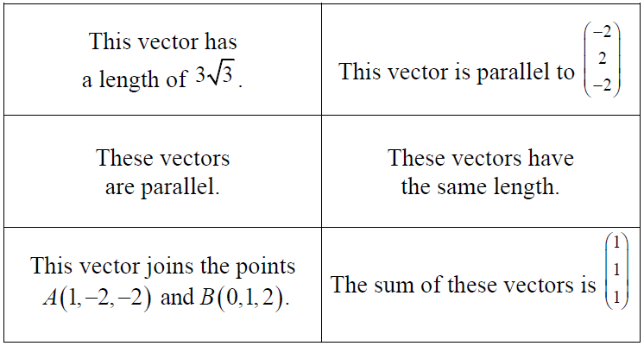

Effective use of technology

Link https://www.geogebra.org/m/VHQzeMX9

‘Entering vectors’ (which can be found at www.mei.org.uk/integrating-technology ) explains how to use the 3D features of GeoGebra; this will help students visualise vectors in 3D.

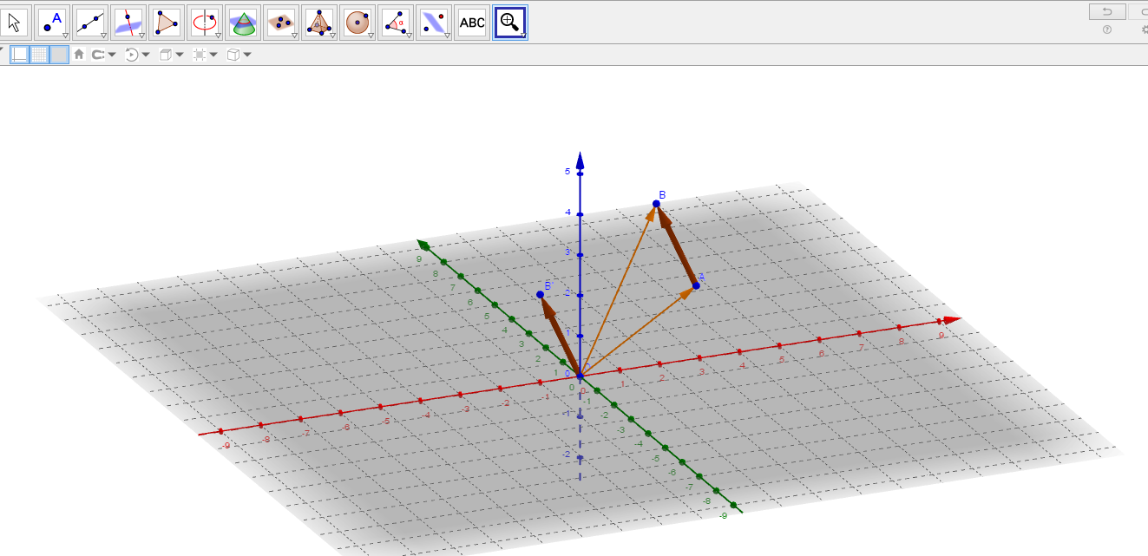

Vectors | Time allocation:
Pre-requisites

- Basic trigonometry: to convert between the different forms in which vectors can be expressed
- Pythagoras’ Theorem to calculate distances between points.
- Vectors (AS) required for the A level unit

Links with other topics

- Polar coordinates in Further Maths: magnitude-direction form is similar to the way a point’s position is described using polar coordinates
- In mechanics quantities which have both magnitude and direction, such as force and velocity, are described by vectors

Questions and prompts for mathematical thinking
- Change one component of so that one vector is parallel to the vector sum of the other two.
- Give me an example of a vector in 3D with magnitude ….now give me an unusual example.

Opportunities for proof

- Varignon’s Theorem: For any quadrilateral, the midpoints of the sides form the vertices of a parallelogram.

Common errors

- Taking insufficient care with notation, such as writing 5 rather than
- Confusing position vectors with displacement vectors

