**Differential equations**

|  |  |
| --- | --- |
| **G6** | Construct simple differential equations in pure mathematics and in context, (contexts may include kinematics, population growth and modelling the relationship between price and demand) |
| **H7** | Evaluate the analytical solution of simple first order differential equations with separable variables, including finding particular solutions  (Separation of variables may require factorisation involving a common factor) |
| **H8** | Interpret the solution of a differential equation in the context of solving a problem, including identifying limitations of the solution; includes links to kinematics |

**Commentary**

Differential equations (DEs) are equations involving an unknown function and its derivatives. ‘First order’ indicates that only the first derivative of the function will be included in the equation. This type of equation can be used to model a wide range of real life situations such as modelling the relationship between price and demand, population growth and scenarios in kinematics.

For any continuously changing phenomena, in order to produce a mathematical model, the most effective starting point is usually to express the changes observed in terms of DEs. Being able to solve these DEs allows us, assuming the model is sufficiently accurate, to predict future behaviour of the system. Where an initial model is not sufficiently accurate, DEs provide an opportunity to explore the modelling cycle.

In A level we only scratch the surface of DEs, looking at those with separable variables; these are ones which can be expressed in the form . In this way, the general solution to  can be found but not to a DE such as . Software such as Autograph is useful here; the tangent lines illustrating what the DE is describing whilst showing both the family of solutions and, given an initial or boundary condition, the particular solution.

Students should note that one important aspect of solving differential equations is that the solution will be a function rather than a single numerical value or set of values, as is more usually the case when they have previously solved equations.

Students commonly find the process of producing a differential equation to represent a situation quite demanding, however mastering this process is beneficial in subsequent interpretation of the solution of an equation in context. In kinematics, for example, recognising ‘acceleration’ as ‘the rate of change of velocity over time’ (i.e. $)$ is an important stage in formulating and interpreting differential equations and their solutions.

**Sample MEI resource**

‘The world population’ (which can be found at <https://my.integralmaths.org/integral/sow-resources.php>) is an OCR(MEI) A level Mathematics comprehension paper from 2012: a seven-page article followed by related questions. The start of the article is shown below; students are then introduced to two models based on differential equations which attempt to model this data. The article goes on to look at population profiles and the roles of birth rate and life expectancy.

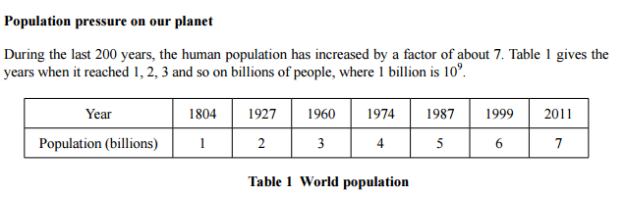

**Effective use of technology**

Explore the logistic equation. In Autograph enter  and explore the role of the 2 and of the 3 in this DE. Think how such an equation can provide a mathematical model for a scenario which has naturally occurring asymptotic behaviour; see, for example, the sample MEI resource above.

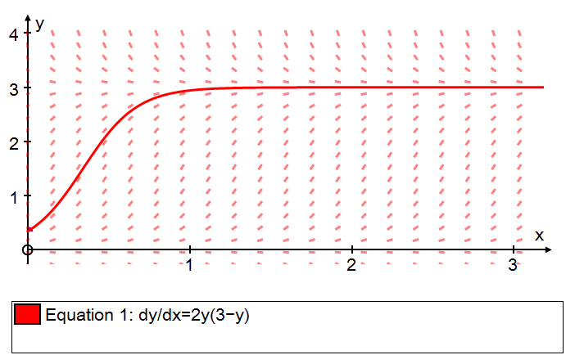

|  |  |
| --- | --- |
| **Differential equations** | **Time allocation:** |
| **Pre-requisites**   * Integration: all A level techniques could be required when solving DEs * Algebra: some DEs will require an algebraic fraction to be written in partial fraction form | |
| **Links with other topics**   * Kinematics: DEs are often useful when modelling a kinematics scenario * Logarithms and exponentials: the solution of many DEs involves logarithmic or exponential functions | |
| **Questions and prompts for mathematical thinking**   * Describe which features of  make it an example of a DE in which the variables are not separable. * How would you explain why there is more than one function, , satisfying the DE ? * What is the same and what is different about the DEs  and ? | |
| **Opportunities for modelling**   * Measure the temperature of a cup of coffee from pouring at 1 minute intervals. Plot the data and model using an exponential decay model. * Fill a 2 litre plastic bottle with water and pierce a hole in the bottom. Do not replace the cap. Using recordings taken during the first 30 seconds (or as appropriate) model the remaining volume as a function of time. | |
| **Common errors**   * Difficulties rearranging expressions involving logarithms. For example,  and showing this is equivalent to * Errors interpreting negative rates of change and handling these in the formation of DEs in context questions * Dealing with the constant of integration where at least one term involves a logarithm. | |