**Numerical Methods**

|  |  |
| --- | --- |
| **I1** | Locate roots of  by considering changes of sign of in an interval of on which is sufficiently well-behaved  Understand how change of sign methods can fail |
| **I2** | Solve equations approximately using simple iterative methods; be able to draw associated cobweb and staircase diagrams  Solve equations using the Newton-Raphson method and other recurrence relations of the form  Understand how such methods can fail |
| **I3** | Understand and use numerical integration of functions, including the use of the trapezium rule and estimating the approximate area under a curve and limits that it must lie between |
| **I4** | Use numerical methods to solve problems in context |

**Commentary**

From their GCSE studies, students are likely to be familiar with finding approximate solutions to equations numerically using iteration and estimating the area under a curved graph. As part of this work they will be familiar with the suffix notation used in recursive formulae.

There are many situations where numerical methods are necessary, for example in calculus, and in solving equations that cannot be solved analytically, such as. Numerical methods are not the poor relation to analytical methods, they are necessary and important.

This topic offers the opportunity to make coherent links across several areas of pure mathematics. For example, in a discussion of, ‘Why can change of sign methods fail on a function that has discontinuities or repeated roots?’ there is the opportunity to draw out the importance of sketching a graph with key features labelled. Similarly, whilst the derivation of the Newton-Raphson formula is not required, finding an opportunity to demonstrate it provides scope for developing a deeper understanding of the mathematical thinking underpinning the method, relying only on the equation of a line and ideas from prior study of differentiation.

When estimating the area under a curve using the trapezium rule, students should be thinking about the degree of accuracy and why increasing the number of strips improves the accuracy of the estimate. This forms a helpful basis for understanding the method of integration as the limit of the sum of an increasing number of strips in a region.

Students should be encouraged to use their calculator efficiently, including the ANS button and memory functions where applicable. Spreadsheets are also a useful tool, allowing a large number of iterations to be carried out relatively quickly. This topic lends itself to an investigative approach using and comparing a range of methods to solve a problem.

**Sample MEI resource**

‘Investigating Iterative Formulae’ (which can be found at <https://my.integralmaths.org/integral/sow-resources.php>) encourages students to explore various rearrangements of an equation in order to produce an iterative formula which homes in on a root of the equation. The resource describes a collaborative poster activity and gives some suggested prompt questions for the teacher. The activity allows students to explore various aspects of the topic, including representing staircase and cobweb diagrams, and when these methods can fail to produce the desired solution.

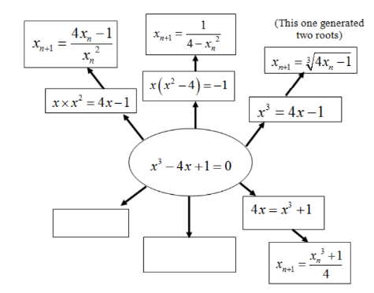

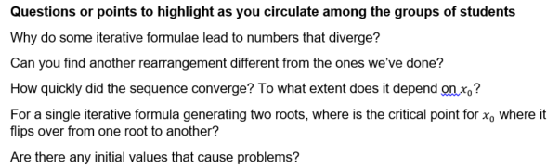

**Effective use of technology**

‘The trapezium rule’ (which can be found at [www.mei.org.uk/integrating-technology](http://www.mei.org.uk/integrating-technology)) is a GeoGebra file illustrating the use of the trapezium rule for numerical integration. The combination of graphical and spreadsheet display illustrate how the accuracy of the approximation increases as the number of trapezia increases. The file easily allows different functions to be explored and the upper and lower limits changed.

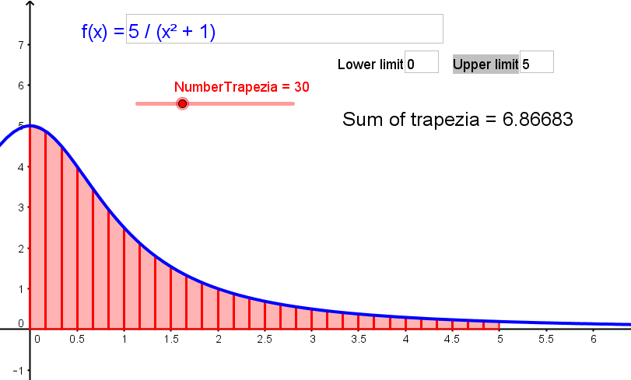

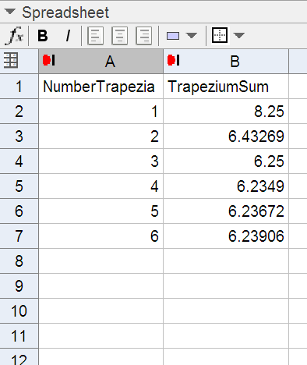

|  |  |
| --- | --- |
| **Numerical Methods** | **Time allocation:** |
| **Pre-requisites**   * Sequences: understanding of limit, convergence, divergence * Differentiation: differentiation of a range of functions required for the Newton-Raphson method * Integration: the concept of integration as finding the area under a curve | |
| **Links with other topics**   * Cubic polynomials: using polynomial division some cubic equations can be solved by first factorising into linear and quadratic terms, for other cubic polynomials numerical methods are useful. * Further numerical integration: using a combination of trapezium and midpoint rules to determine bounds for the answer correct to a desired level of accuracy | |
| **Questions and prompts for mathematical thinking**   * Investigate the sequence . [Why does this generate the square root of ?] * Use three different numerical methods to find a root of the equation * Explain why some iteration processes result in cobweb diagrams whilst others result in a staircase diagram. * Explain connections between the Newton-Raphson method and tangents to the curve. | |
| **Opportunities for proof**   * Prove that for all suitable starting values, the iteration  converges to . * Demonstrate the derivation of the Newton-Raphson formula. * Show that if an iteration has a limit , then  must be a root of the corresponding equation. | |
| **Common errors**   * Giving a numeric solution without stating the error bounds * Inability to link  relationships to their graphical interpretation; e.g. to explain why a starting value didn’t lead to finding the root to which it was closest. | |