Probability

M2 | Understand and use conditional probability, including the use of tree diagrams, Venn diagrams, two-way tables  Understand and use the conditional probability formula
M3 | Modelling with probability, including critiquing assumptions made and the likely effect of more realistic assumptions

Commentary

At AS level students calculate probabilities involving independent events, at A2 they will work with events which are not independent, such as when we sample without replacement.

Working with small examples in Venn Diagrams, such as whether the students in your class study Art and/or Biology, can help to build up the understanding of how some extra information about a student, for example that they study Biology, can affect the probability that they study Art. The sample space can be seen to change from the entire class to just those who study Biology.

A fantastic task to demonstrate the connections between Venn diagrams, two-way tables and tree diagrams is to take some information represented in one format and display it in the other two – perhaps in a ‘Chinese Whisper’s’ style activity.

Students should be aware of the assumptions which are usually made when working with a binomial distribution. Often when sampling from a large population we assume that sampling with replacement leads to independent events (such as picking three people from the adult population of the UK and calculating the probability of selecting three females). We often assume independence when, for example, rolling two dice, although the dice may touch or interact (every object exerts a small amount of gravitational impact on another) it is assumed not to affect the random outcome, and other assumptions such as the dice will not end its roll balancing on a vertex.

Conditional probability can be very counter-intuitive, and it is certainly worthwhile to discuss and analyse situations involving rare events and the possibility of false positives, such as ‘If I test positive for a rare disease, how likely am I to have it?’ The athlete drug testing resource gives a good approach to such questions.

Sample MEI resource

‘Huge Venn’ (which can be found at https://my.integralmaths.org/integral/sow-resources.php) uses Venn diagrams to introduce the notation used in probability and the concept of conditional probability.

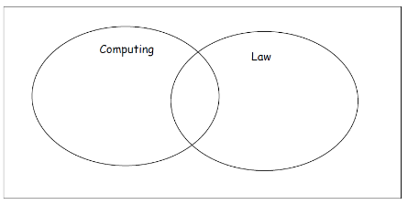

From the students responses it will be possible to derive the formula for conditional probability.

Effective use of technology

‘Rare Events’ (which can be found at http://www.mei.org.uk/integrating-technology) encourages students to think about how rare events can lead to inappropriate conclusions being drawn. The context is around athletics and detecting drugs cheats.

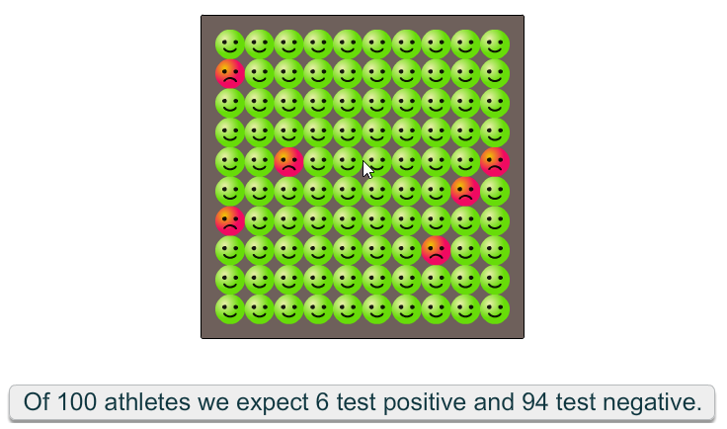
Probability | Time allocation:
Pre-requisites

- Probability AS: Builds on probability work

Links with other topics

- Probability (AS): Showing how independent events can be defined by $P\left(A∩B\right)=P\left(A\right)×P\left(B\right)$ and $P\left(A | B\right)=P(A)$

Questions and prompts for mathematical thinking

- How can you tell events are independent from a tree diagram? From a Venn Diagram? From a two-way table? Which representation makes it easier to see independent events?

Opportunities for proof

- If $A$ and $B$ are independent can you prove that $A'$ and $B'$ are also independent?

Common errors

- The formula for $P(A|B)$ is used with denominator$P(A)$ rather than $P(B)$
- Being able to generate correct Venn diagrams from given information.
- Making an inappropriate choice of method; e.g. using fractions rather than combinations.

