**Kinematics**

|  |  |
| --- | --- |
| **Q3** | Understand, use and derive the formulae for constant acceleration  for motion in a straight line using vectors in 2d |
| **Q4** | Use calculus in kinematics for motion in a straight line using vectors in 2d: |
| **E9** | Use trigonometric functions to solve problems in context, including problems involving vectors, kinematics and forces |

**Commentary**

The extension of the techniques to 2D greatly increases the scope, sophistication and general interest of the scenarios that can be investigated; these may involve constant or variable acceleration. Students should be encouraged to see the practical applications of their calculations. When dealing with kinematics in more than one dimension, students will learn how important it is to use proper notation and to set out solutions clearly.

The ability to draw diagrams that clearly establish the origin and the direction taken as positive is absolutely essential; without such diagrams students will struggle to produce consistent working when they are dealing with scenarios involving several objects starting at different times and/or places.

A particularly interesting technique is that of establishing the cartesian equation of the path of an object moving in 2D with position given in terms of time. An example is

, where length and time are in metres and seconds and where **i** and **j** are unit vectors in the directions of the standard coordinate axes O*x* and O*y*. This would give . Such problems will always contain one component no more complicated than a linear expression in *t*.

**Sample MEI resource**

‘General Motion’ (which can be found at <https://my.integralmaths.org/integral/sow-resources.php>) requires students to produce solutions to two questions. Cards containing parts of each solution are given to the students and they have to organise the cards to create a coherent solution. There may be additional cards that are not required or it may be that students feel that a step is missing from the solution and they can then fill that in on a blank card.

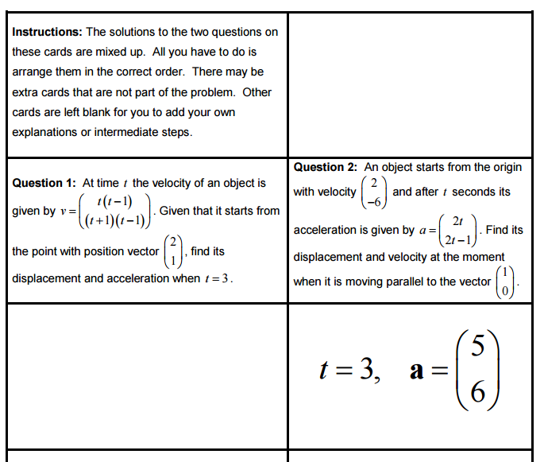

**Effective use of technology**

This ‘2D Exam question’ file (which can be found at <http://www.mei.org.uk/integrating-technology>) is designed to develop a standard exam question (OCR M1 Jan 2007 Question 6 which involves 2D motion described by  ) to prompt further discussion and encourage students to ask additional questions.

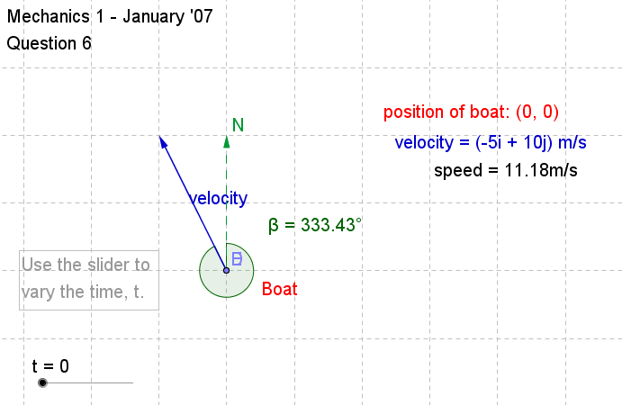

|  |  |
| --- | --- |
| **Kinematics** | **Time allocation:** |
| **Pre-requisites**   * Confidence with simple differentiation and Integration from AS. * Use of constant acceleration ideas from AS. | |
| **Links with other topics**   * Direct application of Differentiation and Integration for variable acceleration problems. * Trigonometry. | |
| **Questions and prompts for mathematical thinking**   * What questions might you ask based on the following scenario?   An aircraft is dropping a crate of supplies on to level ground. Relative to an observer on the ground, the crate is released at the point with position vector  and with initial velocity  , where directions are horizontal and vertical. Its acceleration is modelled by | |
| **Applications and Modelling**   * Relative to an origin on a long, straight beach, the position of a speedboat is modelled by a vector  where and  are unit vectors perpendicular and parallel to the beach. Distances are in metres and the time  is in seconds.   Suggest why this model for the motion of the speedboat is unrealistic for large . | |
| **Common Errors**   * Remembering that when constants of integration are vectors they will have two components. * Combining components when applying calculus techniques in vectors. * Use of displacement instead of velocity to determine direction | |