**Force and motion**

|  |  |
| --- | --- |
| **R2** | Understand and use Newton’s second law for motion in a straight line; extended to situations where forces need to be resolved. |
| **R4** | Understand and use Newton’s third law; equilibrium of forces on a particle and motion in a straight line application to problems involving smooth pulleys and connected particles; resolving forces in 2 d; equilibrium of a particle under coplanar forces |
| **R5** | Understand and use addition of forces; resultant forces; dynamics for motion in a plane. |

**Commentary**

The topics in this section will enable many students to enjoy a real sense of satisfaction as they compare the outcomes of their calculations with their own experiences. For instance, calculating the force acting between the floor of a lift and their feet when the lift is moving upwards and decelerating lets them interpret the ‘light’ feeling they have all experienced in that situation.

Good diagrams are always helpful (and often essential) so students need a lot of practice to ensure they understand how to draw and use them. Time spent on this early in a course is a good investment.

Many of the scenarios require the student to use the fact that Newton’s laws are vector statements and so may be applied to the components in any selected direction; an important skill is to be able to choose a direction that simplifies subsequent working, another is to be able to resolve accurately in any direction chosen or specified.

When several objects are connected together, such as the engine and trucks of a train on a *straight* track, parts of the system may be grouped together and then treated as connected objects. When connected objects are not in a straight line, say a block on a plane connected by a string passing over a smooth pulley to a freely hanging heavy object, it is bad practice to try to write down equations of motion or equilibrium equations ‘round the corner’; students should always produce separate equations for each object. In this example, each equation will contain a tension term of the same magnitude in the appropriate direction.

Students should develop a good understanding of Newton’s third law, which describes the relationship between the forces acting on objects. There are several examples of poor technique or misunderstandings which are often seen and have to be addressed. For instance not making it clear on diagrams that the two parts of the ‘equal and opposite’ pairs of forces act on *different* objects.

**Sample MEI resource**

The ‘Newton’s Laws Experiments’ (which can be found at <https://my.integralmaths.org/integral/sow-resources.php>) is an excellent resource to encourage students to experience and visualise scenarios based around force and motion. It gives the opportunity to confront and deal with some of the misconceptions they hold and also provokes discussion about the modelling that is involved.

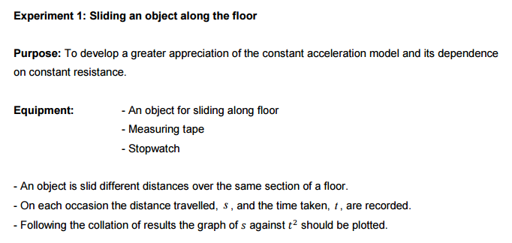

**Effective use of technology**

This ‘Resolving forces Exam Question’ file (link can be found at [www.mei.org.uk/integrating-technology](http://www.mei.org.uk/integrating-technology)) is designed to develop a standard exam question (OCR M1 Jan 2007 Qn 4 which involves resolving forces of magnitude 20N and 16N inclined at 60°) to prompt further discussion and encourage students to ask additional questions.

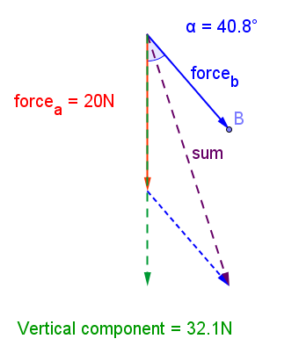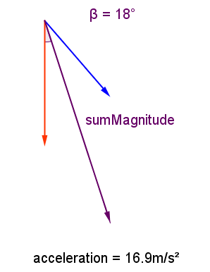

Questions to ask students:

* What happens as I vary the angle that force B makes with the vertical?
* What happens when forces A and B are perpendicular?
* What do you notice about the acceleration as you change the angle?

|  |  |
| --- | --- |
| **Forces and motion** | **Time allocation:** |
| **Pre-requisites**   * Basic trigonometry to resolve forces. * Linear and simultaneous equations from GCSE | |
| **Links with other topics**   * Connection to GCSE Trigonometry | |
| **Questions and prompts for mathematical thinking**   * Two boys try to stretch a spring using the two methods shown in the   diagram.    By which method is it easier to stretch the spring and why? | |
| **Applications and Modelling**   * Investigate the relationship between the two masses and the resulting acceleration. | |
| **Common Errors**   * The misconception that sustained motion requires a continued force. * Getting sine and cosine mixed up when resolving forces * When applying  , instead of resolving, or attempting to resolve, the force down the slope (line of motion), attempting to resolve the ‘ma’ as well and writing . * Ignoring the weight component, or non-resolution of it, in . | |