Moments (A level)

S1 | Understand and use Moments in simple static contexts

Commentary

This is a small part of the mechanics specification but makes an important contribution to the learners’ ability to model commonly occurring scenarios. Up to this point, all the applications of forces to problems involving static equilibrium have been modelled by forces acting on a particle or on connected particles connected by light strings or light rods. Our learners are all very familiar with situations where the physical size of an object is an essential determinant of its response to the application of an external force because the turning effect of the force has to be modelled and this cannot, of course, be done with a particle model. Who hasn’t put a cup of tea on a tray and then put the tray down on a table overlapping its edge to find that the system is not in equilibrium and the tea ends up on the carpet.

Investigation and use of the idea of the turning effect of a force goes back at least to Archimedes (d. 212 BCE) and the ideas have been developed ever since. Only the simplest examples are introduced in this specification but they should be enough give a learners’ a good insight into the key principles. Amongst the most important of these are:

-for a body to be in equilibrium, the external forces acting on the body must have zero sum and the sum of all the moments of these forces about any axis must be zero;

-the turning effect on a body, about an axis, of its weight may be calculated as if the weight acted through a point of the body called its centre of mass; the position of the centre of mass may be given or be found for uniform bodies using arguments based on symmetry.

Sample MEI resource

‘Balancing a ruler’ (which can be found at https://my.integralmaths.org/integral/sow-resources.php) provides an excellent way to motivate the study of moments.

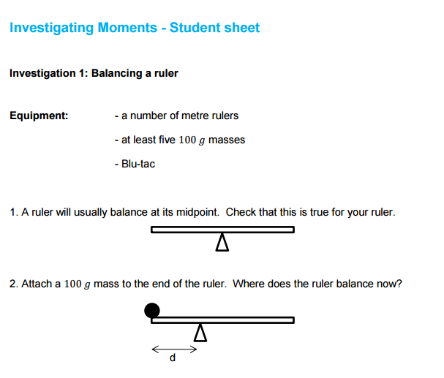
Questions to ask:

- A ruler normally balances at its midpoint. Why is this? Is this always true?
- Attach a 100g mass with the aid of Blu-Tack. Where should it balance now? Roughly? Make a guess….

Effective use of technology

‘Balancing act’ (a link can be found at www.mei.org.uk/integrating-technology) is helpful in getting students to see how the position of the masses can affect the equilibrium of the plank. Where do you position the various masses to ensure the plank is level?

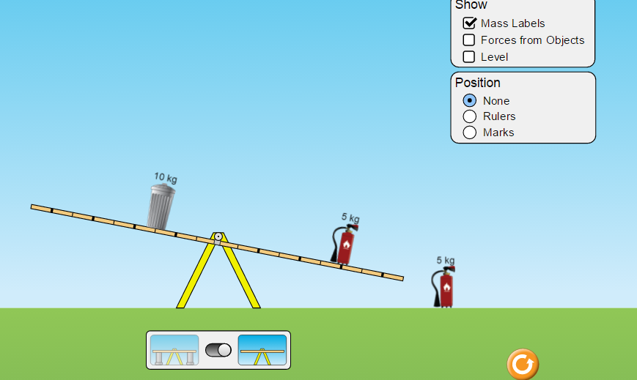

Moments(A level) | Time allocation:
Pre-requisites

- Newton’s Laws of Motion
- Confidence with drawing force diagrams

Links with other topics

- Equilibrium of forces.
- Basic trigonometry when resolving forces

Questions and prompts for mathematical thinking

- If the beam below has length 5m and mass 150kg, what mass could you place on the end so that the beam was just on the point of lifting off one of the supports?
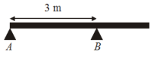

Applications and Modelling

- Why is it safer for a window cleaner to have a partner to stand on the bottom rung? Investigate the problem using a metre ruler, some plasticine and weights.

Common Errors

- Not always getting the direction of the moment correct.
- Forgetting to include reaction forces at a support or hinge in a force diagram.
- An unsuitable choice of point to take moments from leading to an equation with more than the unknown force.

