Projectiles

Q5 | Model motion under gravity in a vertical plane using vectors; projectiles
E9 | Use trigonometric functions to solve problems in context, including problems involving vectors, kinematics and forces

Commentary

Most students really enjoy working on scenarios involving projectiles. It is worth emphasising that, having made a few not unreasonable assumptions, there is a huge range of scenarios that can be investigated with mathematics that only involves constant acceleration equations and the solution of linear and quadratic equations.

The specification refers to a ‘standard projectile model’. The assumptions of this model are that the projectile has negligible size, is subject to negligible air resistance and that the horizontal and vertical distances travelled are sufficiently small for the magnitude and direction of the acceleration due to gravity to remain constant. Students should understand the significance of this model; it will apply in all examination questions unless there is a statement about a different model being used in a particular scenario.

Sample MEI resource

’Projectile problems’ (which can be found at https://my.integralmaths.org/integral/sow-resources.php) encourages students to design their own questions based around a final answer. Different pairs of students are given different problems. Their problems can be verified by exchanging amongst the students. Interesting ideas or uncertainties can be checked during class discussion. For example, is there enough information in the question to answer it?

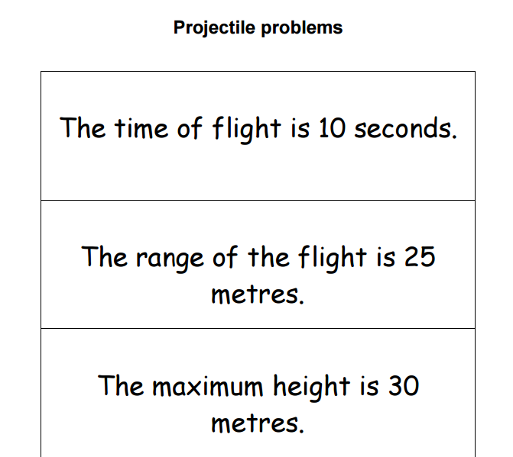

Effective use of technology

‘Trajectory of a projectile’ (which can be found at http://www.mei.org.uk/integrating-technology) is an interactive GeoGebra file. It is designed to investigate how various parameters affect the trajectory of a projectile.

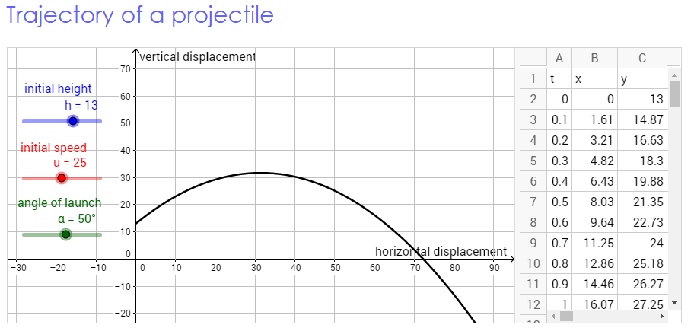

Questions to ask students:

- What would you expect to happen if the angle of launch is zero?
- What angle of launch would maximise the range of a projectile? Why?
- Change the initial height- how does this affect for the particle’s path? Why?

Projectiles | Time allocation:
Pre-requisites

- Constant acceleration ideas from AS.
- Resolving vectors into two components

Links with other topics

- Linear and Quadratic equations
- Trigonometry.

Questions and prompts for mathematical thinking

- A ball is projected under gravity as shown. If air resistance is negligible insert an arrow at each position A, B, and C to indicate the direction of the resultant force acting.

Applications and Modelling

- A firework sends out sparks from ground level with the same speed 20ms⁻¹, in all directions. A spark starts at an angle to the horizontal. Investigate the accessible points for this speed by plotting the trajectory for different values of . (Use 10ms⁻² for g.) Use a graph plotter to check your ideas.
.

Common Errors

- Assuming that a projectile always lands on the same level it started from.
- The force that gives the projectile its initial velocity, does not affect the subsequent motion i.e. when.t>0
- Dealing with negative displacements or getting the value of ‘g’ wrong; e.g. using -9.8 instead of 9.8 if the object began moving downwards initially.

