**Friction**

|  |  |  |
| --- | --- | --- |
| **R6** | Understand and use the  model for friction; coefficient of friction; motion of a body on a rough surface; limiting friction and statics   |  | | --- | |  | |

**Commentary**

A good way to motivate this topic is to ask students to think about situations where friction may be acting and why it might be important. For example, a ladder leaning

against a wall would always slide if there were no friction between the foot of the ladder and the ground. The absence of friction in icy conditions causes difficulties for road users: pedestrians slip over, cars and motorcycles skid.

The model for friction has to be applied carefully. If forces, including friction, are in static equilibrium it may be that the friction is not limiting and so taking *F* = *μR* would be wrong and lead to error. It is best to learn the result as *F* ≤ *μR* or *F*max = *μR* to keep this possibility in mind. Also, students often overlook the possibility that changing one force in a system may alter the normal reaction and hence the limiting frictional force.

**Sample MEI resource**

The ‘Law of friction experiment’ (which can be found at <https://my.integralmaths.org/integral/sow-resources.php>) provides an excellent way to establish the inequality *F* ≤ *μR* as a model for friction.

Students set up equipment as shown in the diagram below and draw a force diagram that represents the scenario:

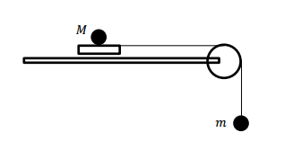

Masses are added to m until the pull on the M causes the block to slide along the table. This is repeated for different values and the results are recorded. Data of Fagainst R are plotted for further investigation.

**Effective use of technology**

‘Forces acting on a box’ is an interactive resource (which can be found at [www.mei.org.uk/integrating-technology](http://www.mei.org.uk/integrating-technology)) designed to explore a model for friction.

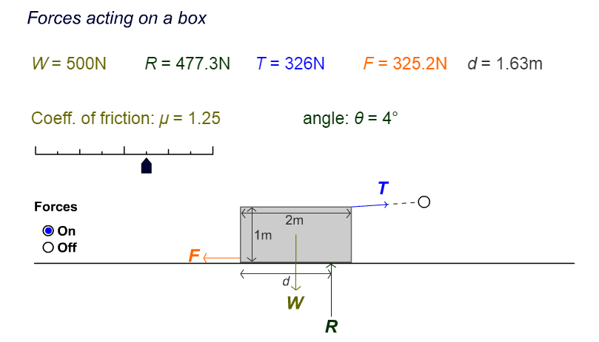

Questions to ask students:

* What do you notice as you change the angle ?
* Under what circumstances does the block move?

|  |  |
| --- | --- |
| **Friction** | **Time allocation:** |
| **Pre-requisites**   * Newton’s Laws of Motion * Resolving forces | |
| **Links with other topics**   * Connection to GCSE Trigonometry | |
| **Questions and prompts for mathematical thinking**   * In what direction is the frictional force between the back wheel of a cycle and the road? | |
| **Applications and Modelling**   * Hold a metre ruler horizontally across your two index fingers and slide your   fingers smoothly together, fairly slowly. What happens?  Use the laws of friction to investigate what you observe. | |
| **Common Errors**     * Using  in inappropriate situations. * Confusing the notation of F in Newton’s Second Law, , and friction. | |